

SAVEETHA INSTITUTE OF MEDICAL AND TECHNICAL SCIENCES

ITA03 Mobile Computing

Lab Manual

1.Use Figma to create an interactive diagram illustrating the components of a basic cellular system.
Aim: -
To create an interactive diagram illustrating the components of a basic cellular system
Procedure: -
1. open Figma
2. Create a new file
3. Select the Frames
4. Fill in the content that is required for presentation
5. Design Visual Elements
6. Make it Interactive
7. Add Annotations and Explanations
8. Incorporate Multimedia
9. Storyboard Animation
11. Review and edit the Prototype
12. Save and Share

Design: -
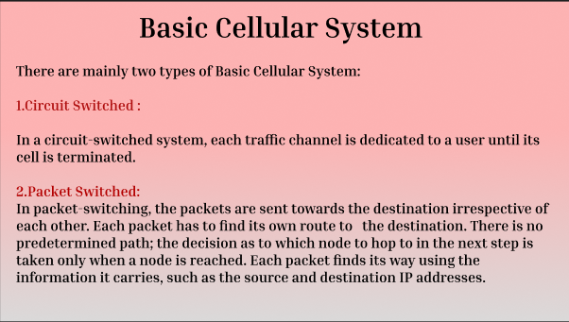
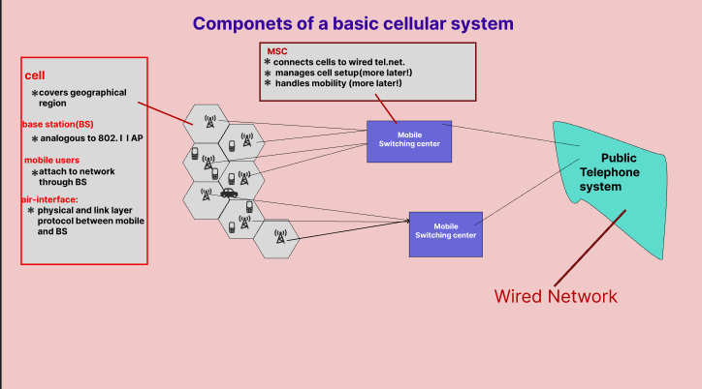

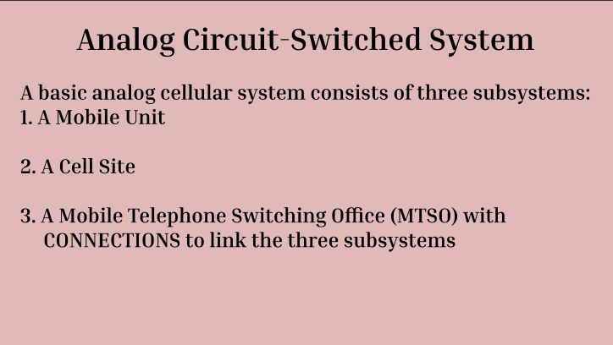

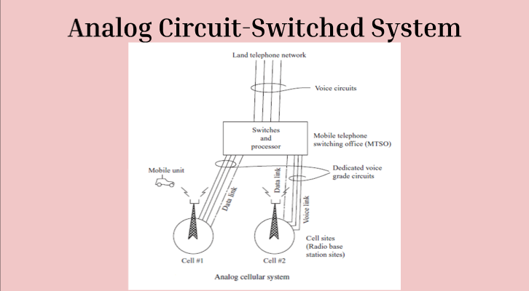

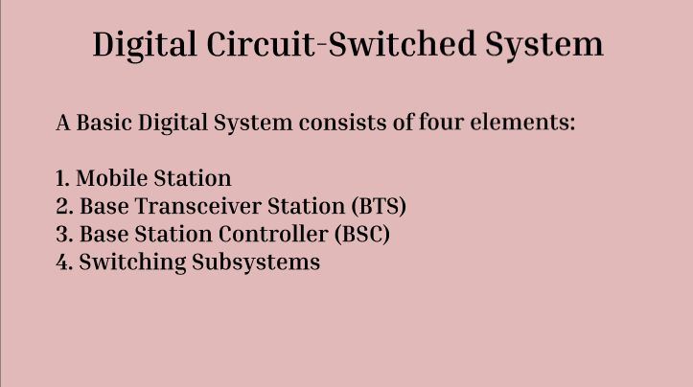

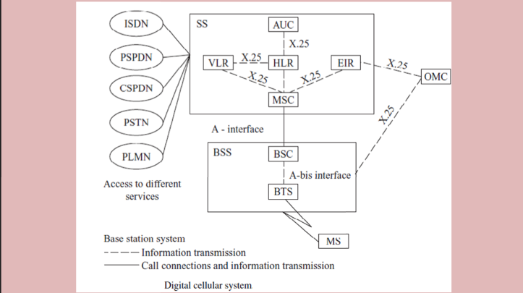

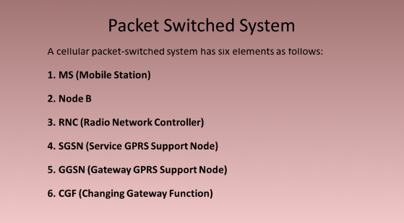

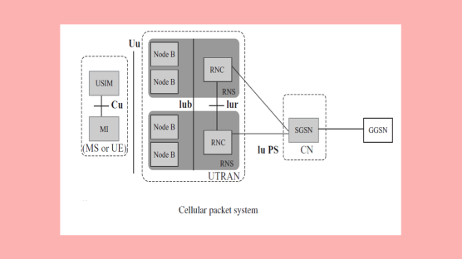

Prototype: -

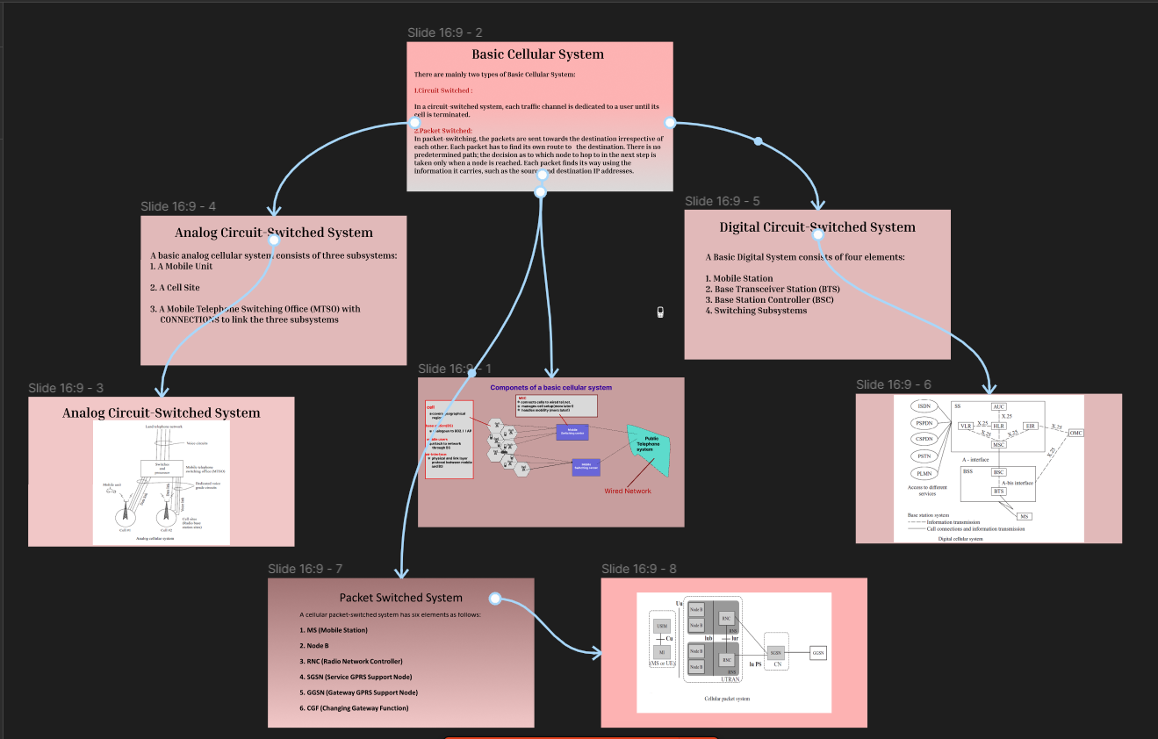
Result: -
Hence an interactive diagram illustrating the components of a basic cellular system using
Figma is created and executed successfully

2.Design a user interface prototype for a mobile station using Figma, considering connectivity and convenience.
Aim: -
To create a user interface prototype for a mobile station using Figma, considering connectivity and convenience.
Procedure: -

1. open Figma
2. Create a new file
3. Select the Frames
4. Design Visual Elements
5. Make it Interactive
6. Add icons on the Frame
7. Incorporate Multimedia
8. Storyboard Animation
9. Review and edit the Prototype
10. Save and Share

Design:-
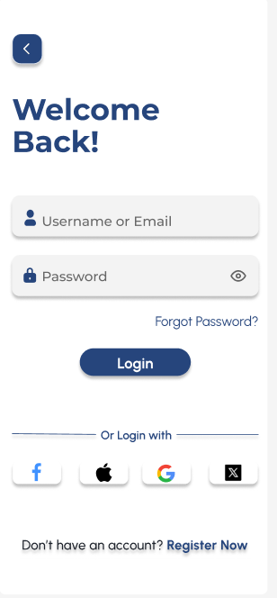
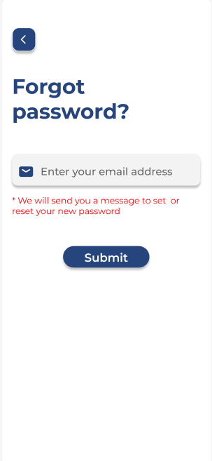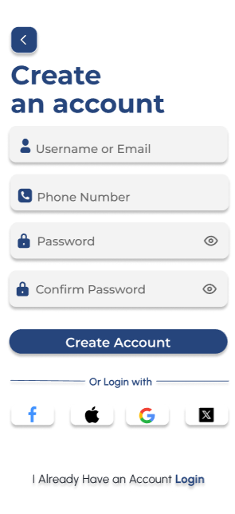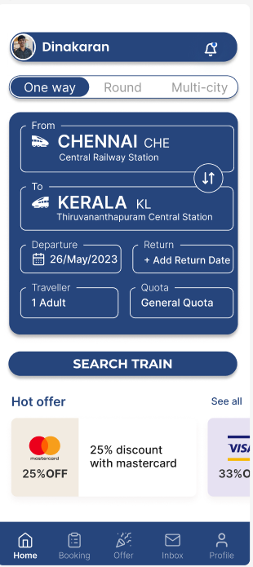

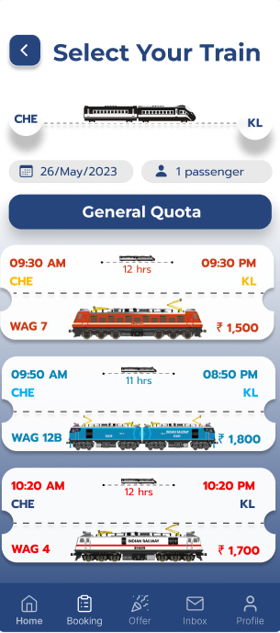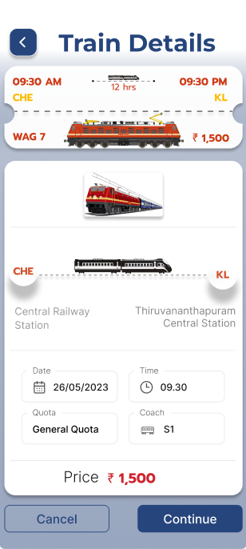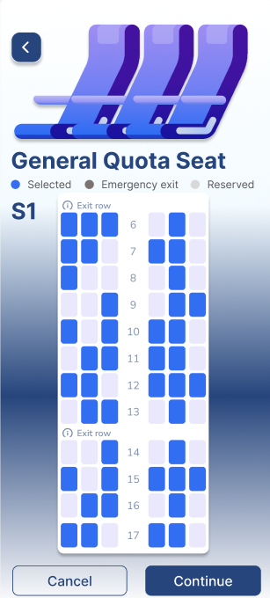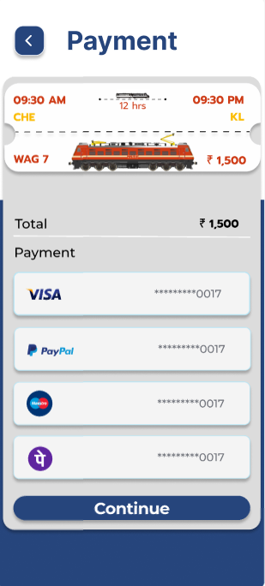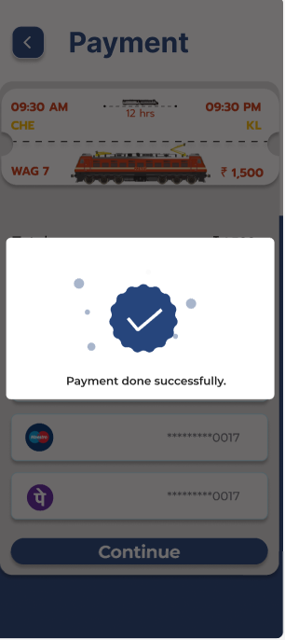

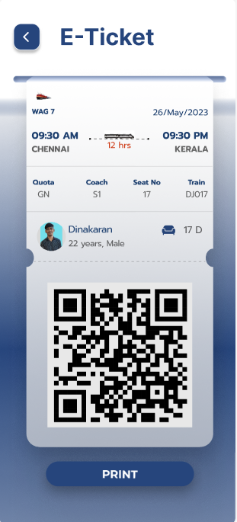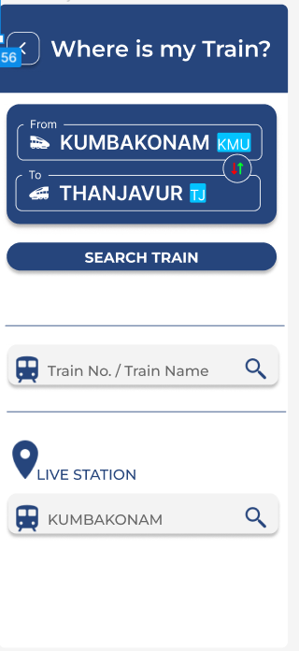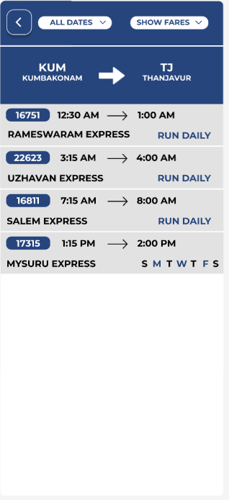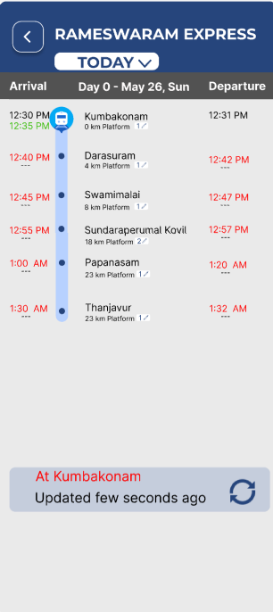

Prototype: -

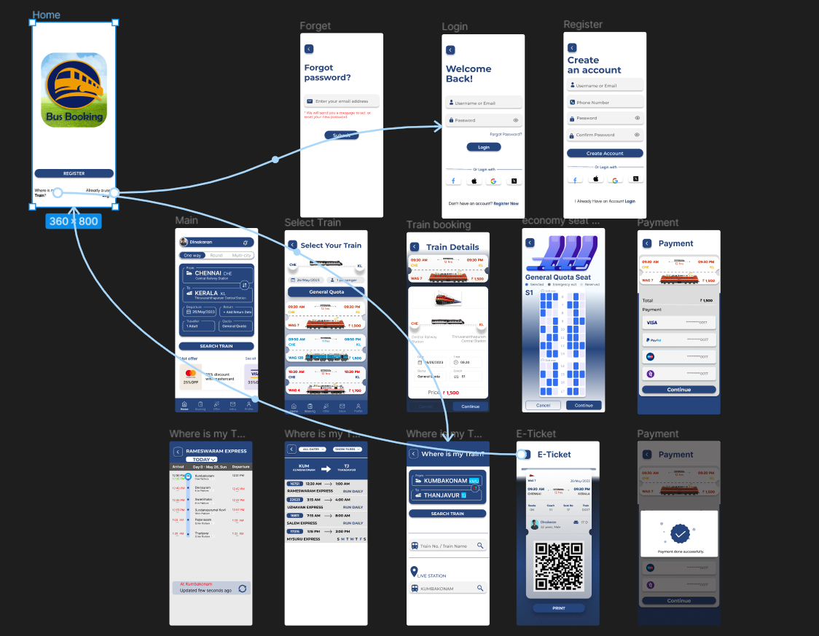

Result: -
A user interface prototype for a mobile station using Figma, considering connectivity and convenience using Figma is created and executed successful

3. Develop a flowchart in Figma depicting the operation of a Network Switching Subsystem in a mobile cellular system.

Aim: -
To draw a flowchart in Figma depicting the operation of a Network Switching Subsystem in a mobile cellular system

Procedure: -
1. open Figma
2. Create a new file
3. Click on the resources icon and click on the plugins

4. Search for the Flow Chart
5. Drag and drop the shapes on the screen
6. Now, enter the content on the shapes and connect them through Arrows.
7. Grouping and alignment
8. Review and edit
9. Save and share

Design: -

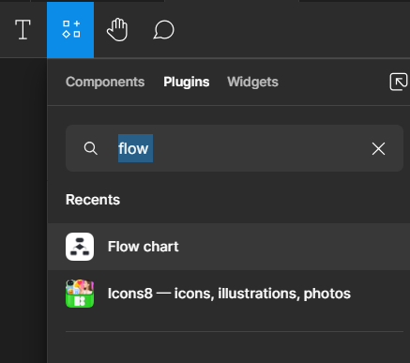

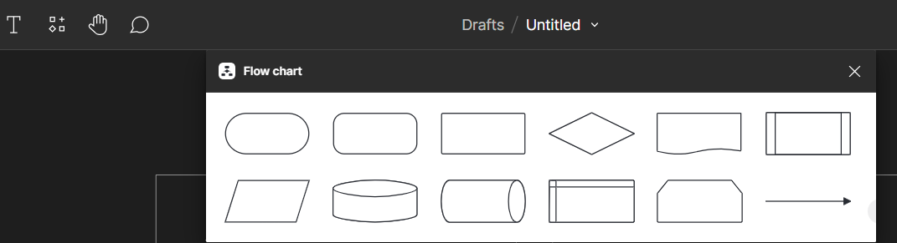
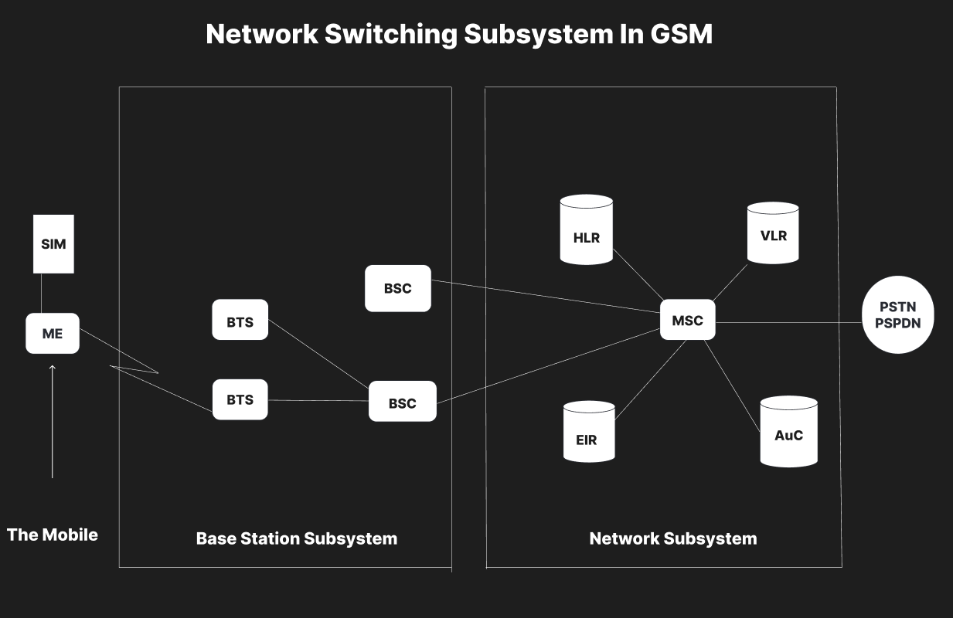

Result: -
Hence the flowchart in Figma depicting the operation of a Network Switching Subsystem in a mobile cellular system has been drawn successfully

4. Create a visual representation in Figma highlighting the key elements of mobile network protocol stacks.

Aim: -
Design a visual representation in Figma highlighting the key elements of mobile network protocol stacks.

Procedure: -
1. open Figma
2. Create a new file
3. Select the Frames
4. Fill in the content that is required for presentation
5. Design Visual Elements
6. Make it Interactive
7. Add Annotations and Explanations
8. Incorporate Multimedia
9. Storyboard Animation
11. Review and edit the Prototype
12. Save and Share

Design: -

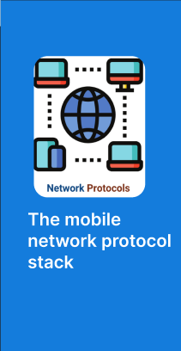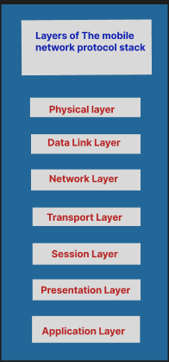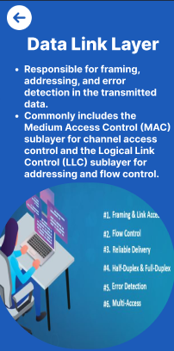

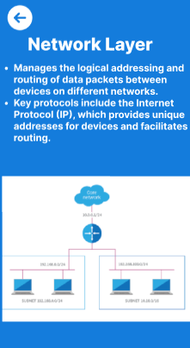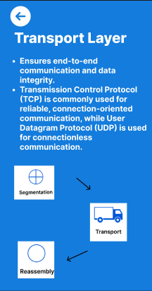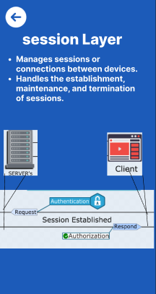

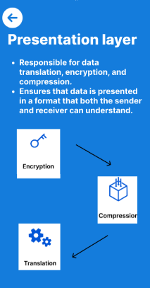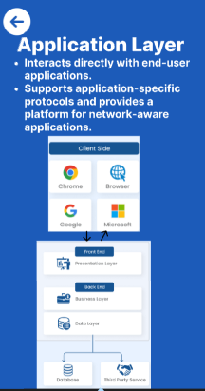

Prototype: -

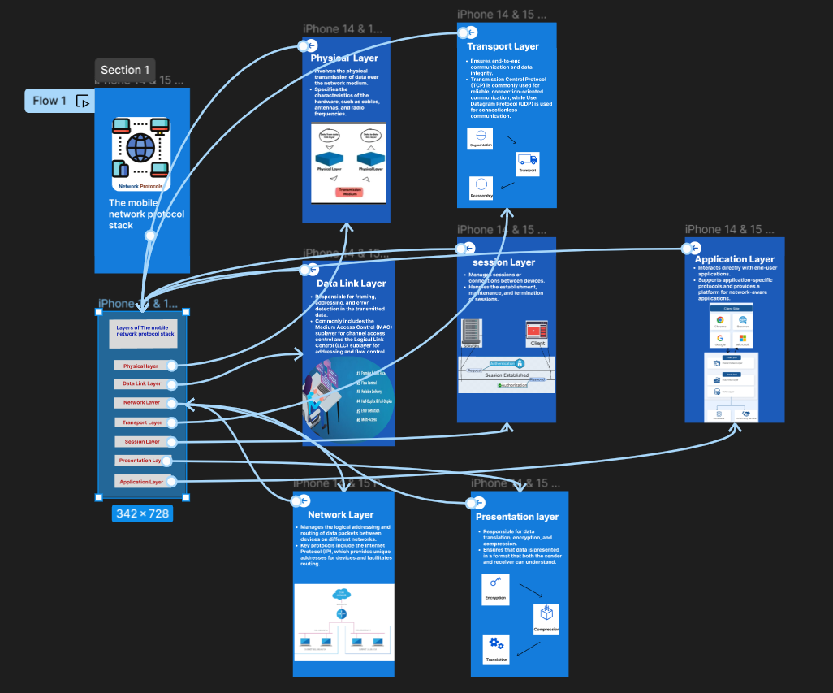

Result: -
Hence the visual representation in Figma highlighting the key elements of mobile network protocol stacks is created and executed successfully

5. Design a wireframe for a mobile application that incorporates localization features using Figma.

Aim: -
To design a wireframe using Figma for a mobile application that incorporates localization features

Procedure: -
1. open Figma
2. Create a new file
3. Select the Frames
4. Design Visual Elements
5. Make it Interactive
6. Add icons on the Frame
7. Incorporate Multimedia
8. Storyboard Animation
9. Review and edit the Prototype
10. Save and Share

Design: -
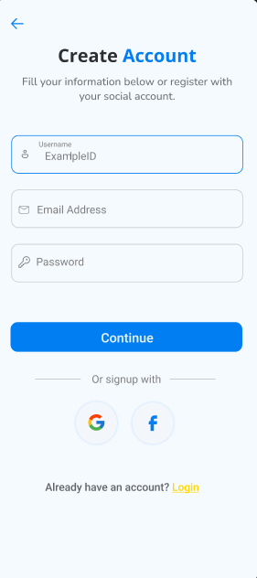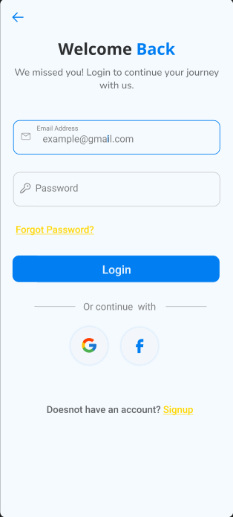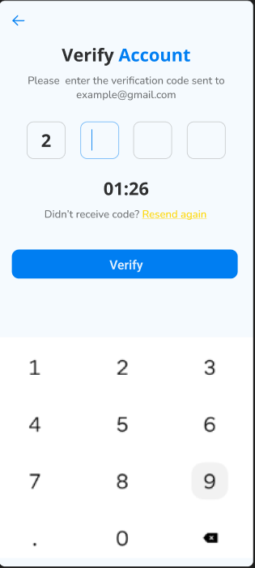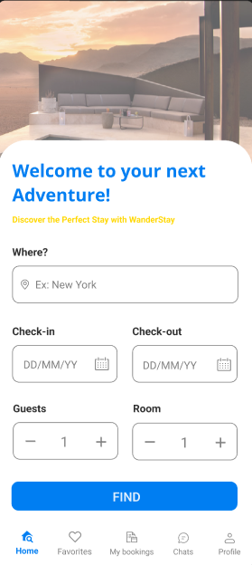

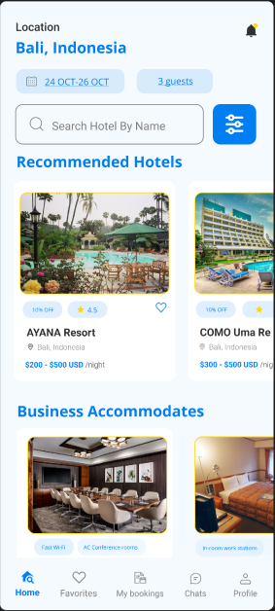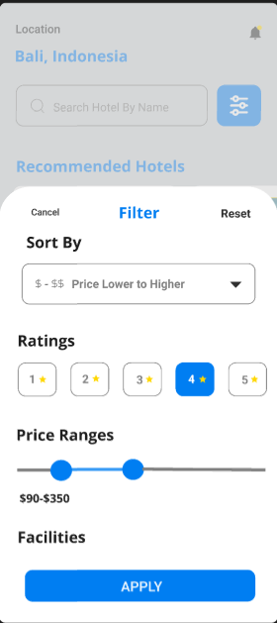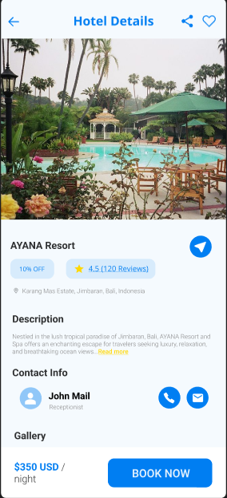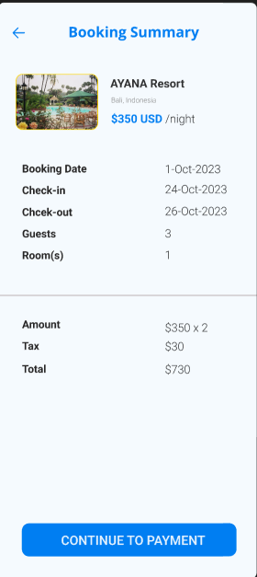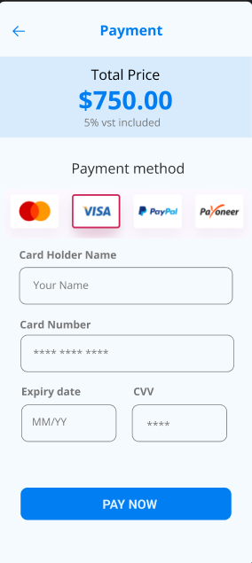

Prototype: -
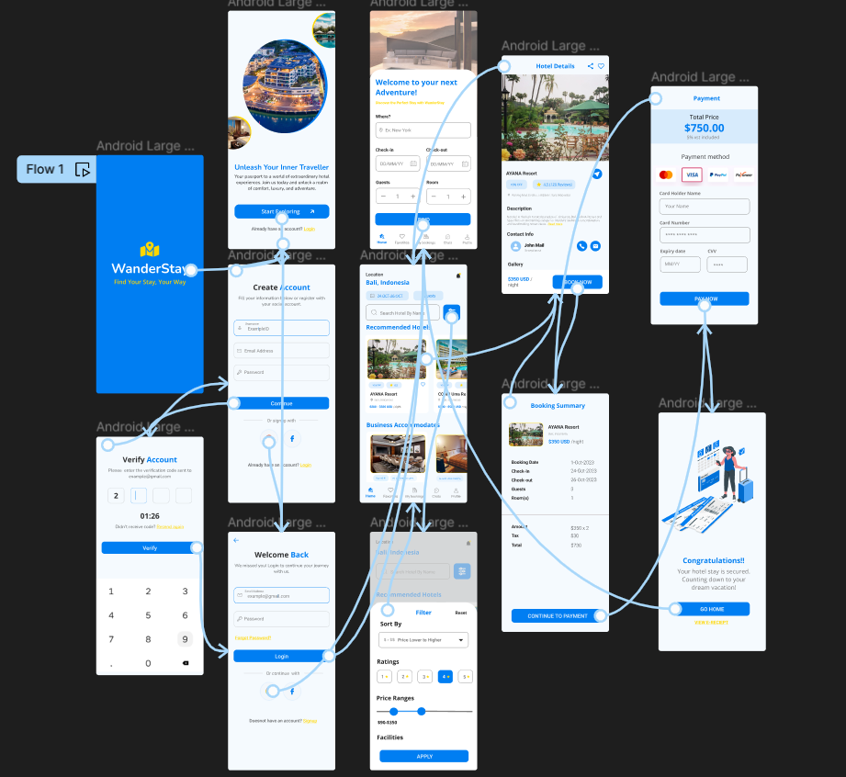

Result: -
Hence the wireframe for a mobile application that incorporates localization features using Figma is created and executed successfully

6. Use Figma to simulate a handoff scenario in a mobile network and visualize the process.
Aim: -To simulate a handoff scenario in a mobile network and visualize the process using Figma.
Procedure:
1. Open Figma
2. Create a new file
3. Select the Frames
4. Fill in the content that is required for presentation
5. Design Visual Elements
6. Make it Interactive
7. Add Annotations and Explanations
8. Incorporate Multimedia
9. Storyboard Animation
10. Review and edit the Prototype
11. Save and Share
Design:
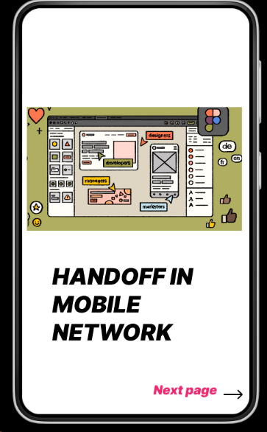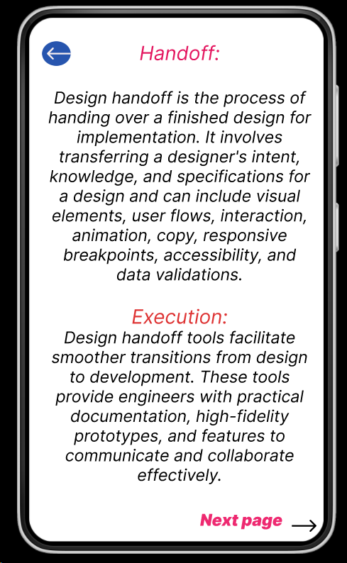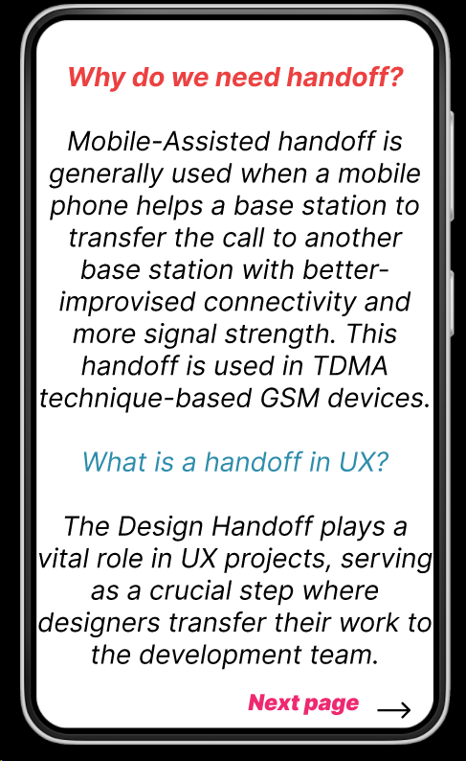

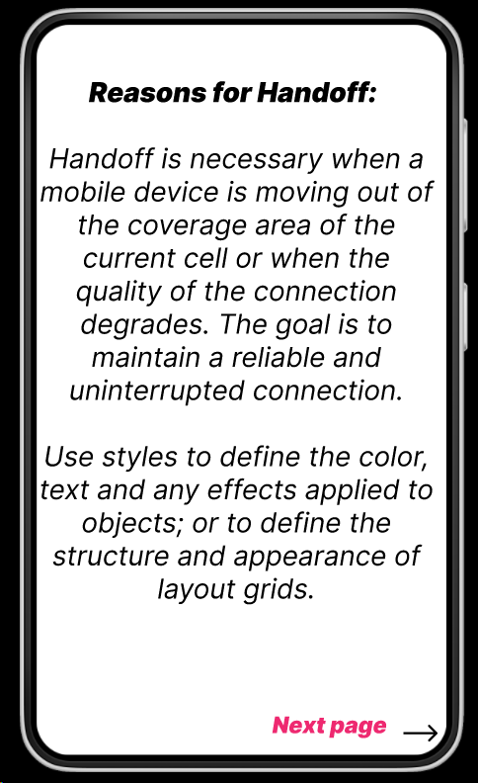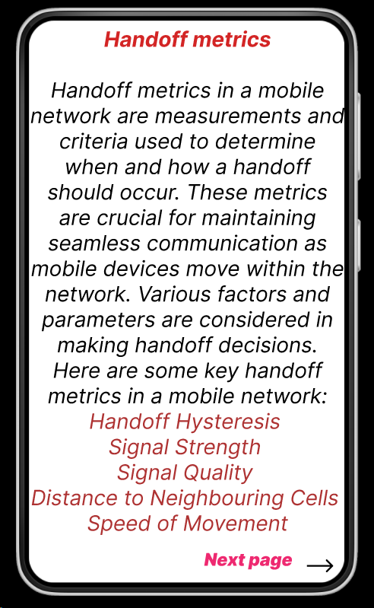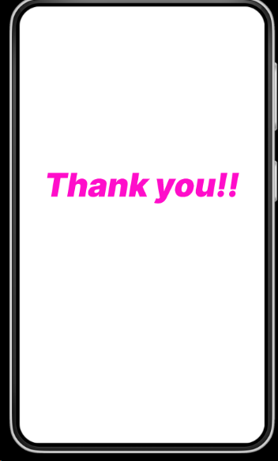

Prototype:
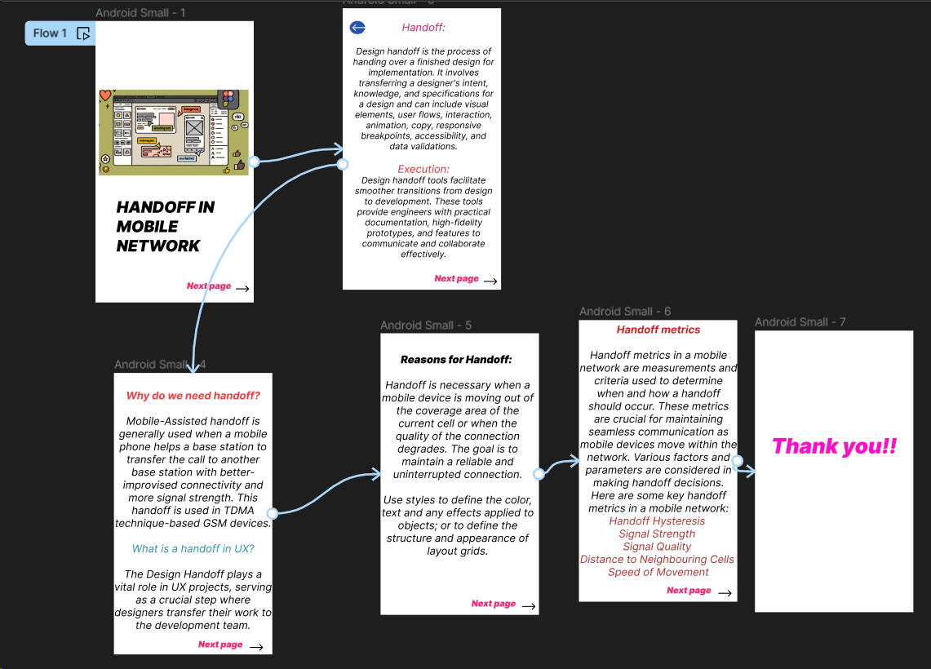
Result:
Hence the simulated a handoff scenario in a mobile network and visualized the process using Figma.
7. Develop a dashboard prototype in Figma displaying performance criteria for a cellular system.

Aim: To develop a dashboard prototype in Figma displaying performance criteria for a cellular system.

Procedure:
1. Open Figma
2. Create a new file
3. Select the Frames
4. Fill in the content that is required for presentation
5. Design Visual Elements
6. Make it Interactive
7. Add Annotations and Explanations
8. Incorporate Multimedia
9. Storyboard Animation
10. Review and edit the Prototype
11. Save and Share
Design:
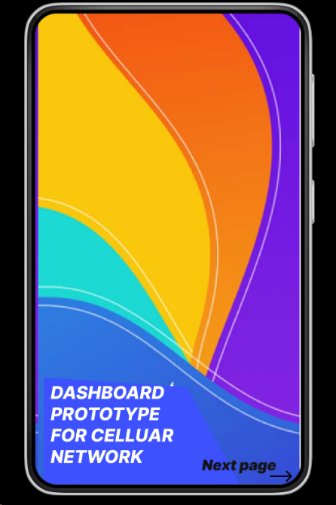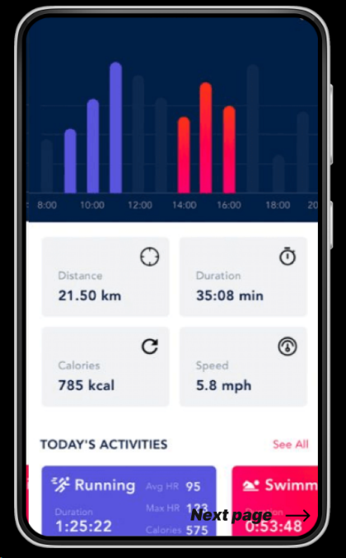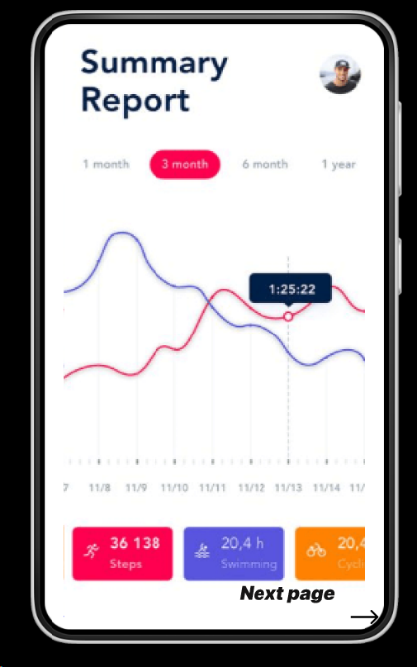

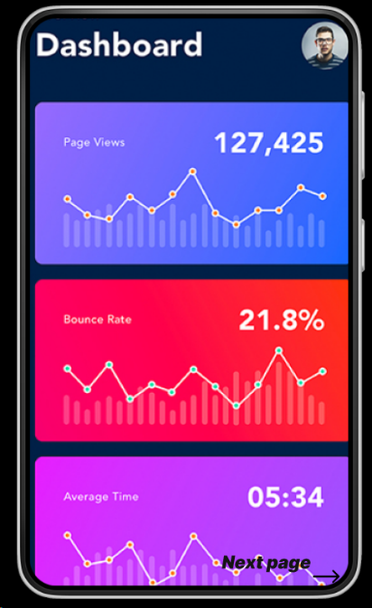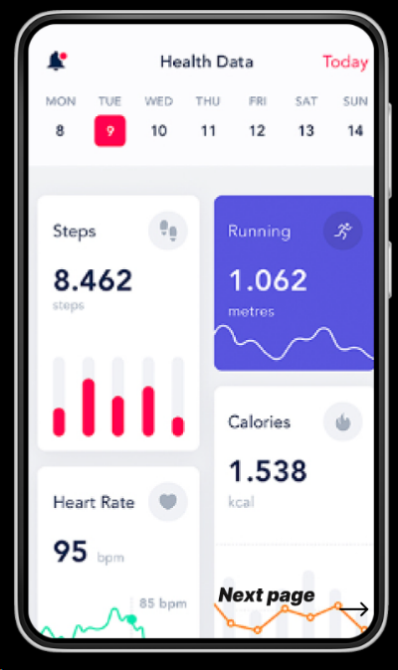
Prototype:
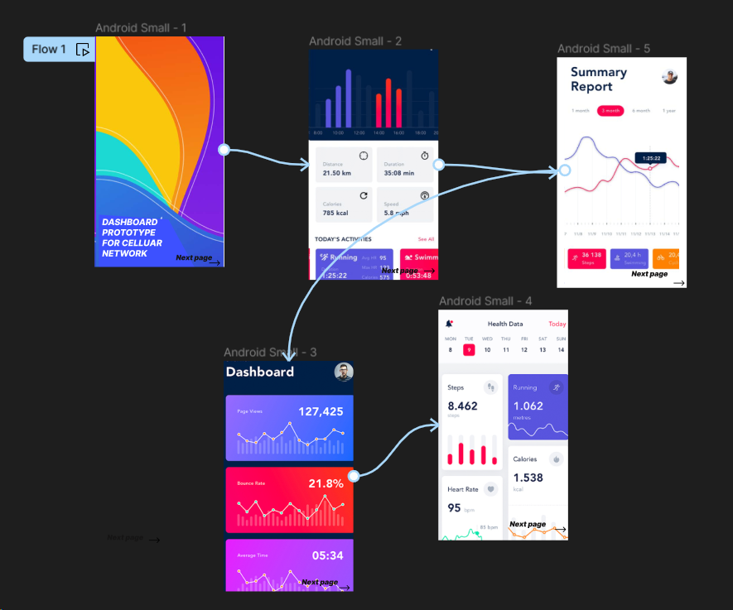
Result:
Hence developed a dashboard prototype in Figma displaying performance criteria for a cellular system.

8. Create an infographic in Figma explaining the concept of Public Land Mobile Network (PLMN).
Aim: To create an infographic in Figma explaining the concept of Public Land Mobile Network (PLMN).

Procedure:
1. Open Figma
2. Create a new file
3. Select the Frames
4. Fill in the content that is required for presentation
5. Design Visual Elements
6. Make it Interactive
7. Add Annotations and Explanations
8. Incorporate Multimedia
9. Storyboard Animation
10. Review and edit the Prototype
11. Save and Share
Design:
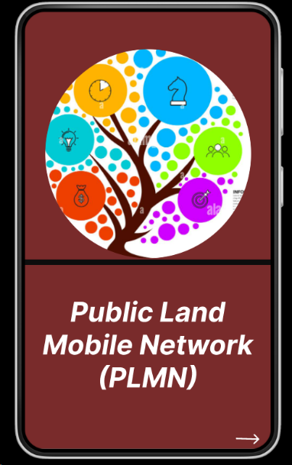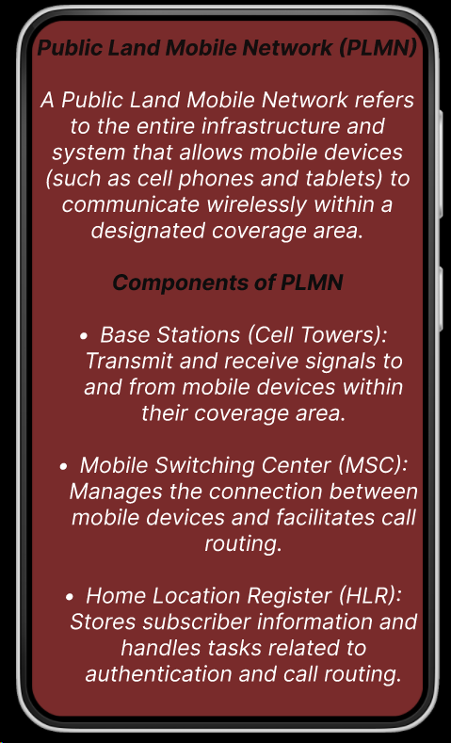
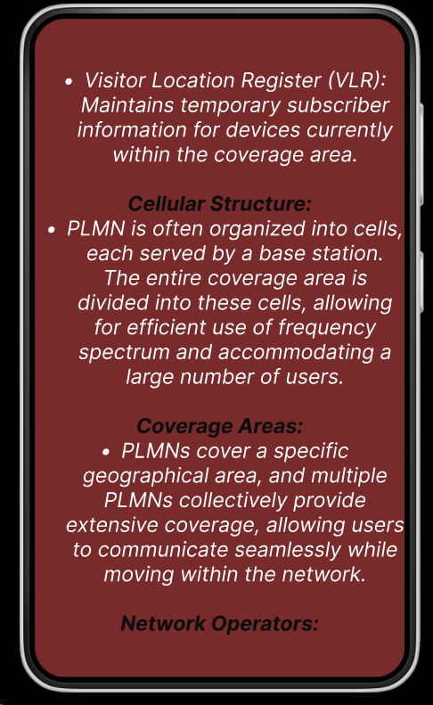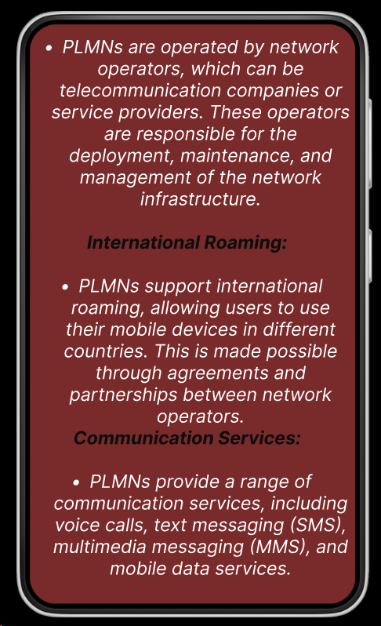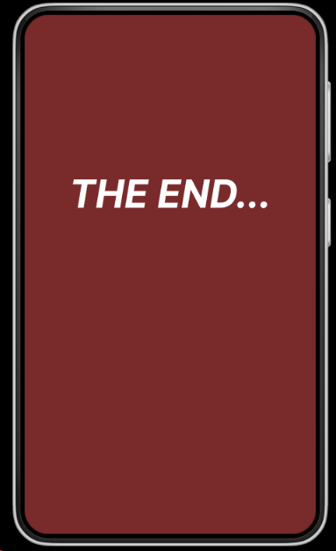

Prototype:
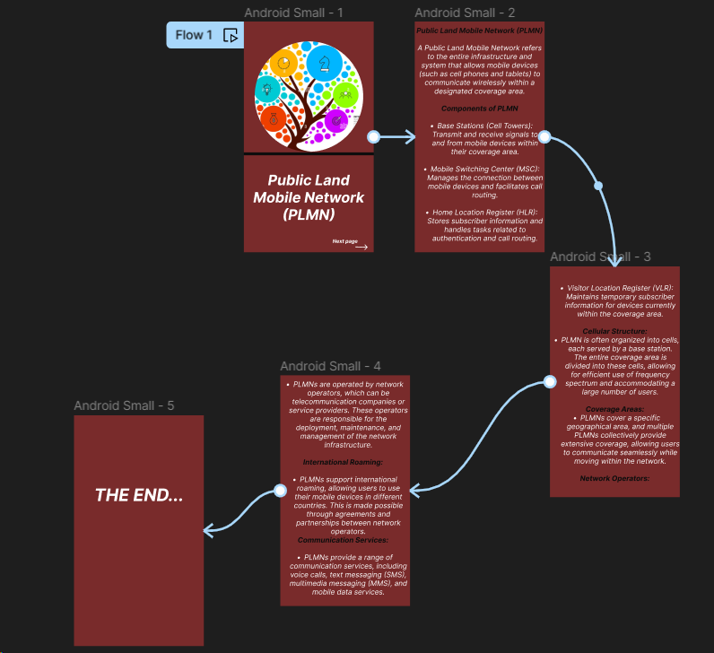
Result:
Hence created an infographic in Figma explaining the concept of Public Land Mobile Network (PLMN).

9. Develop a user interface prototype for a GSM service using Figma.
Aim: To develop a user interface prototype for a GSM service using Figma.

Procedure:
1. Open Figma
2. Create a new file
3. Select the Frames
4. Fill in the content that is required for presentation
5. Design Visual Elements
6. Make it Interactive
7. Add Annotations and Explanations
8. Incorporate Multimedia
9. Storyboard Animation
10. Review and edit the Prototype
11. Save and Share
Design:
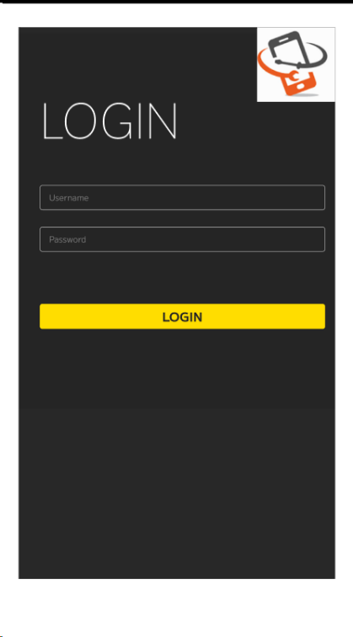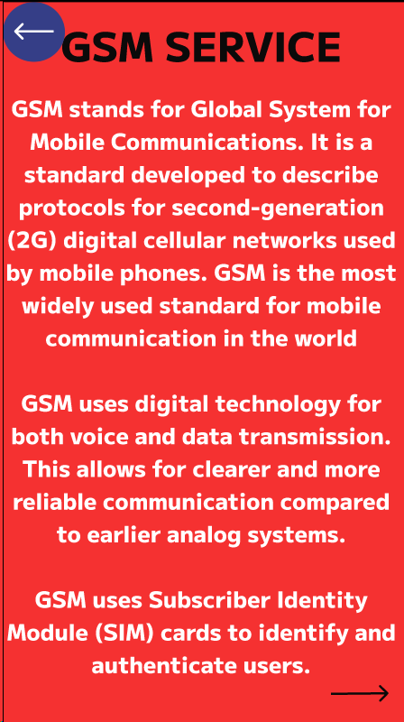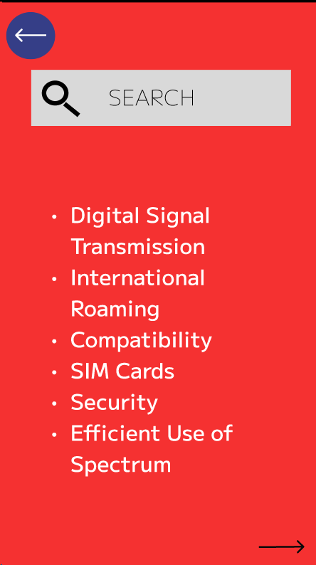
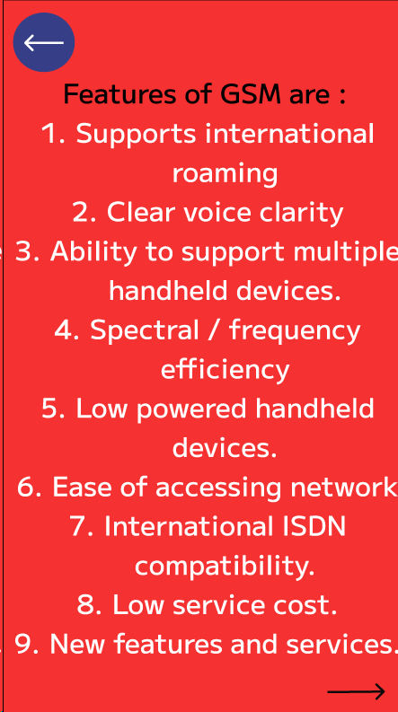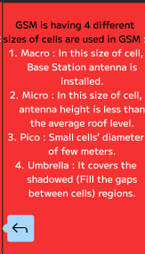
Prototype:
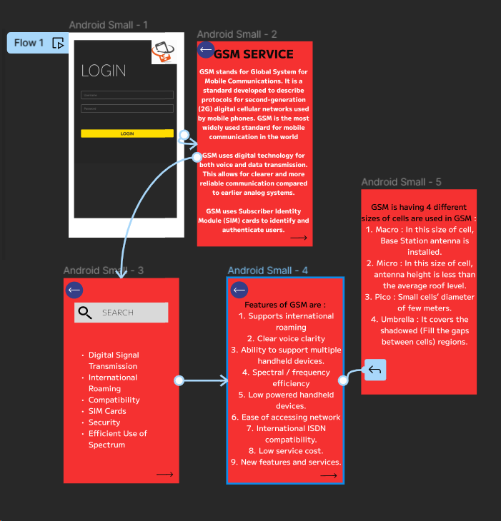
Result:
Hence developed a user interface prototype for a GSM service using Figma.

10. Create a visual representation in Figma showcasing the differences between various multiple access techniques.
Aim: To create a visual representation in Figma showcasing the differences between various multiple access techniques.

Procedure:
1. Open Figma
2. Create a new file
3. Select the Frames
4. Fill in the content that is required for presentation
5. Design Visual Elements
6. Make it Interactive
7. Add Annotations and Explanations
8. Incorporate Multimedia
9. Storyboard Animation
10. Review and edit the Prototype
11. Save and Share
Design:
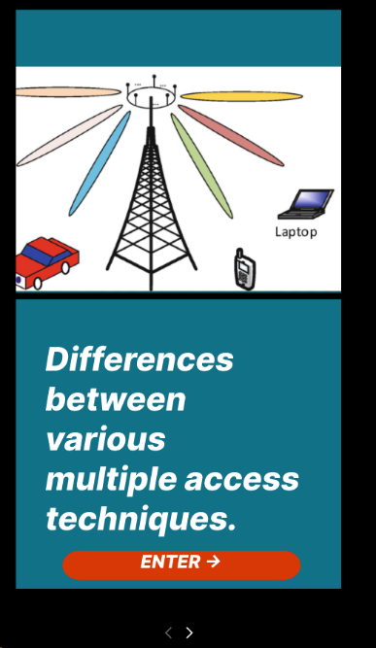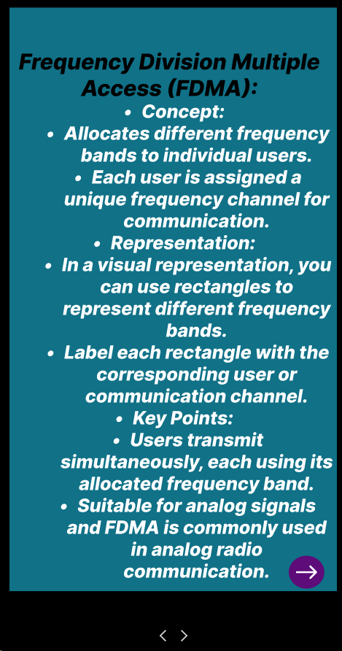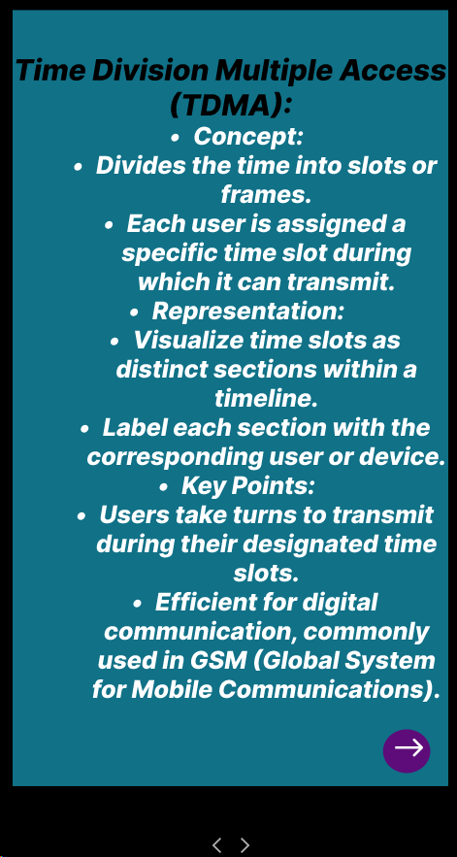
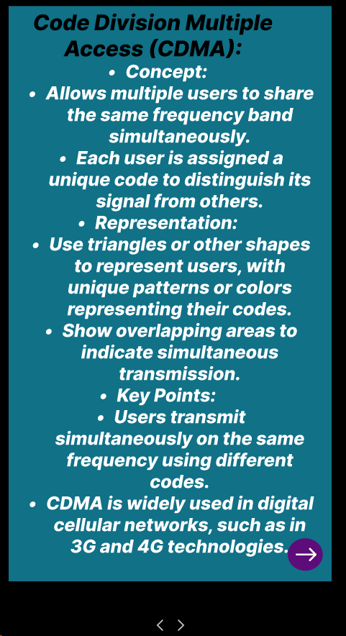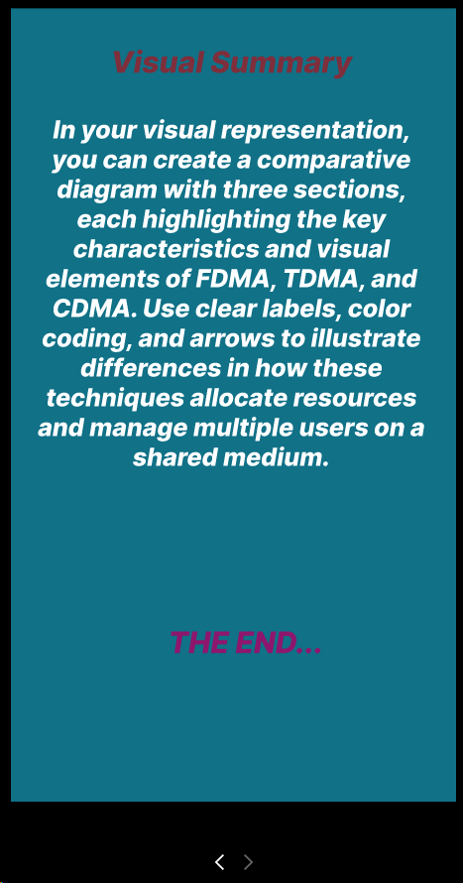
Prototype:
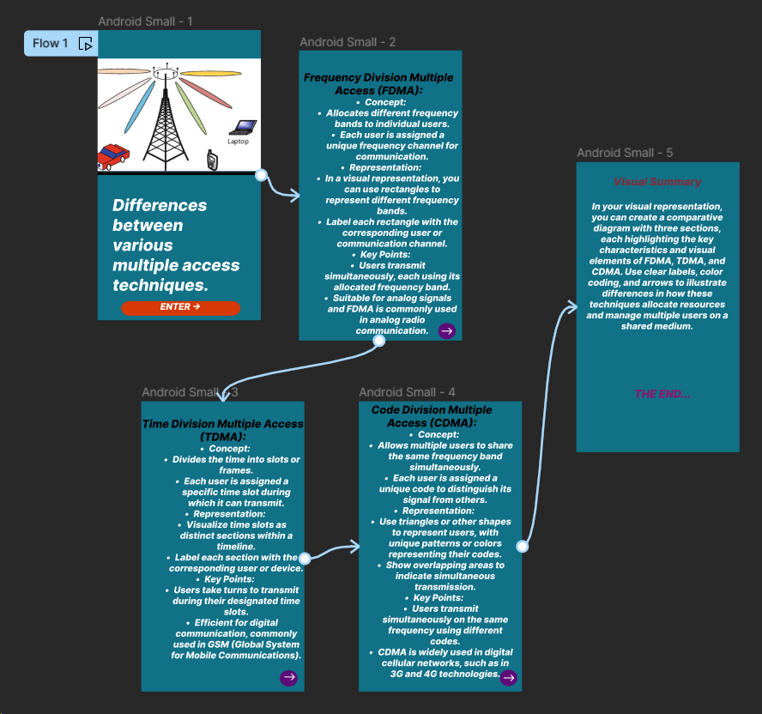
Result:
Hence created a visual representation in Figma showcasing the differences between various multiple access techniques.

11. Design a wireframe for a mobile application that incorporates security measures using Figma.
Aim: -
Using Figma design a wireframe for a mobile application (Bank app UI) that incorporates security measures.
Procedure: -

1. open Figma
2. Create a new file
3. Select the Frames
4. Design Visual Elements
5. Make it Interactive
6. Add icons on the Frame
7. Incorporate Multimedia
8. Storyboard Animation
9. Review and edit the Prototype
10. Save and Share

Design: -

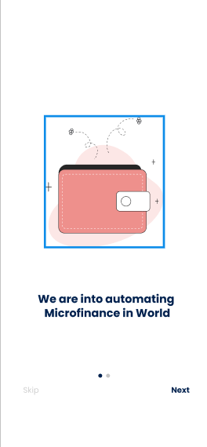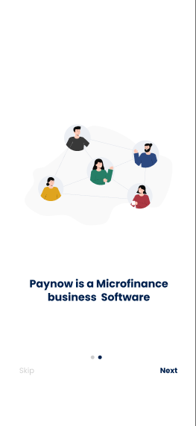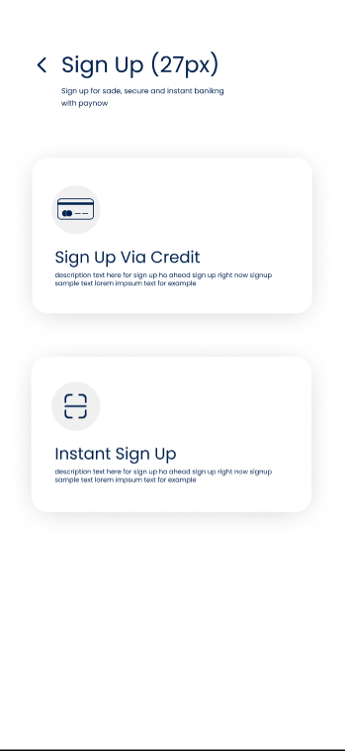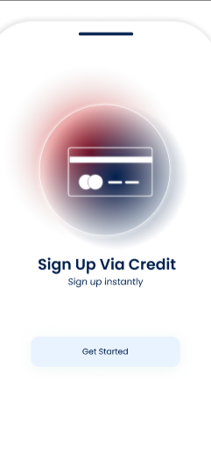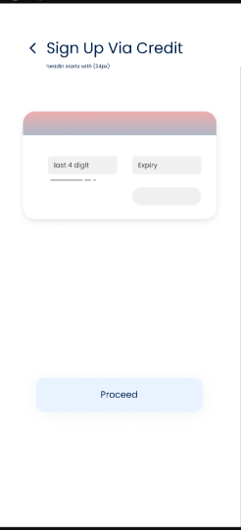

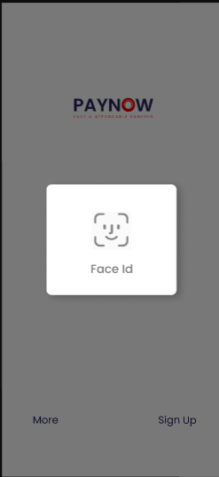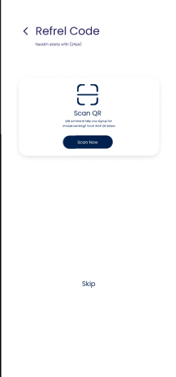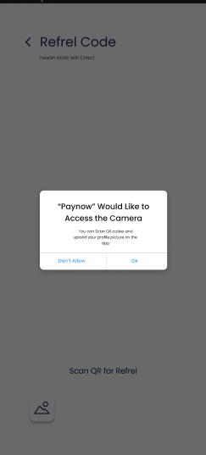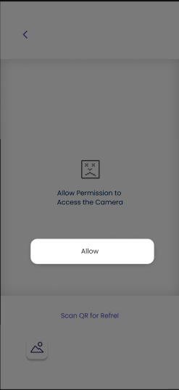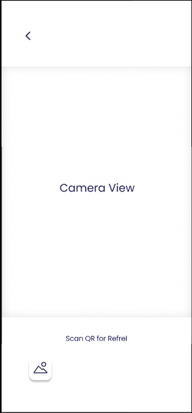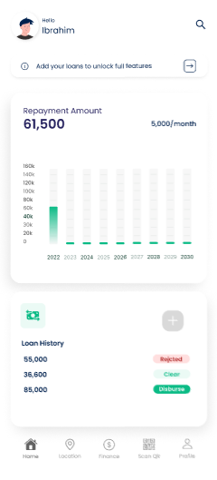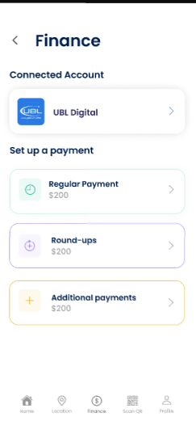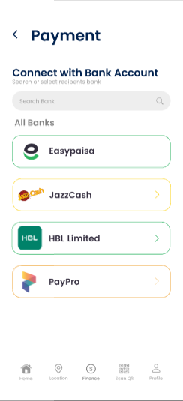

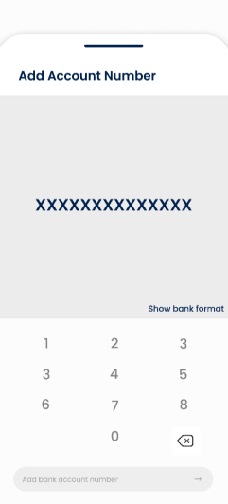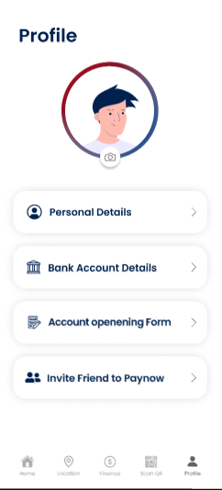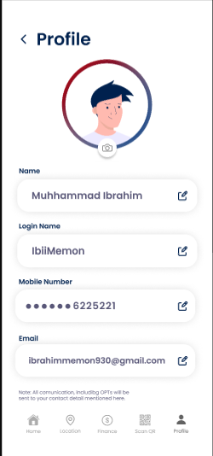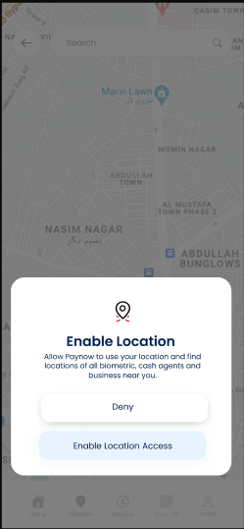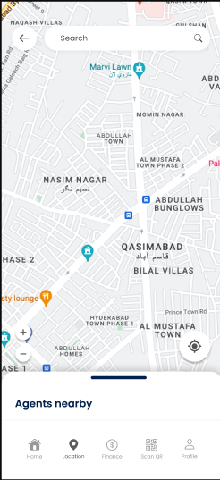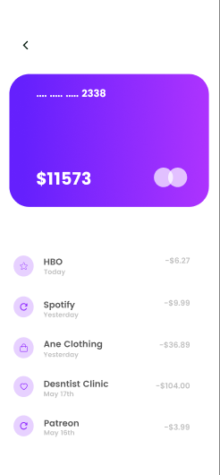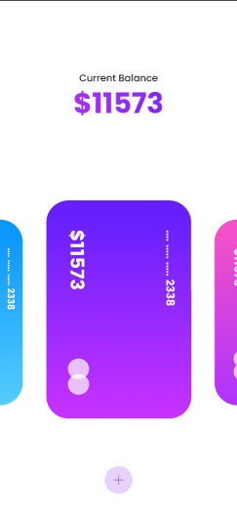

Prototype: -

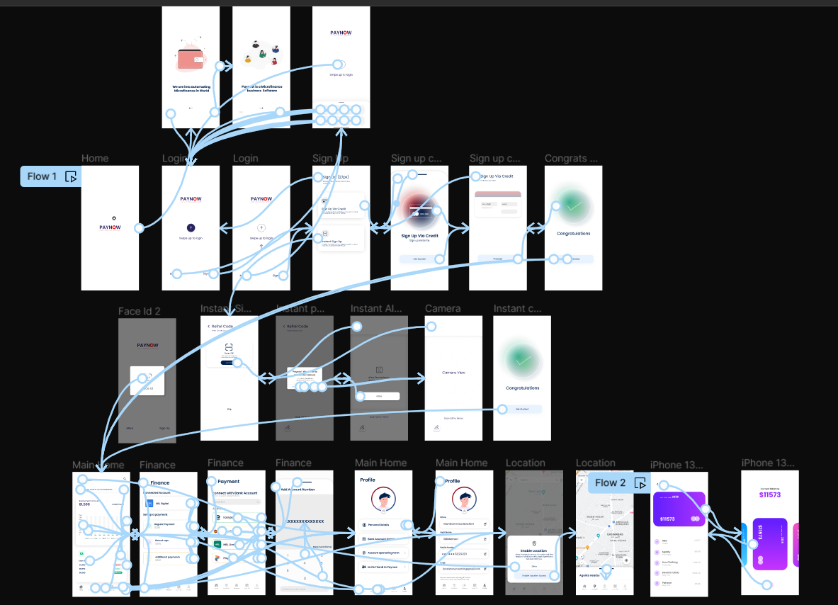

Result: -
A wireframe for a mobile application that incorporates security measures using Figma is created and executed successfully

12. Use Figma to create an interactive diagram illustrating the evolution from 1G to 5G.

Aim: -
Design an interactive diagram illustrating the evolution from 1G to 5G using Figma.

Procedure: -
1. open Figma
2. Create a new file
3. Select the Frames
4. Fill in the content that is required for presentation
5. Design Visual Elements
6. Make it Interactive
7. Add Annotations and Explanations
8. Incorporate Multimedia
9. Storyboard Animation
11. Review and edit the Prototype
12. Save and Share

Design: -

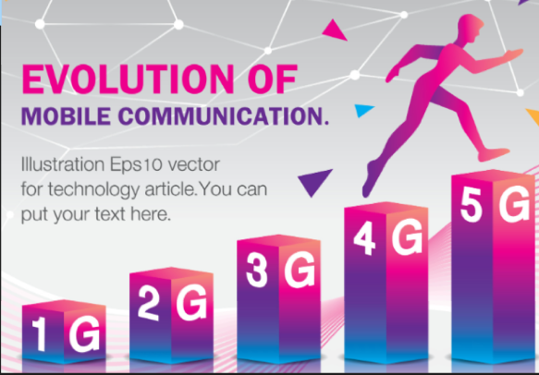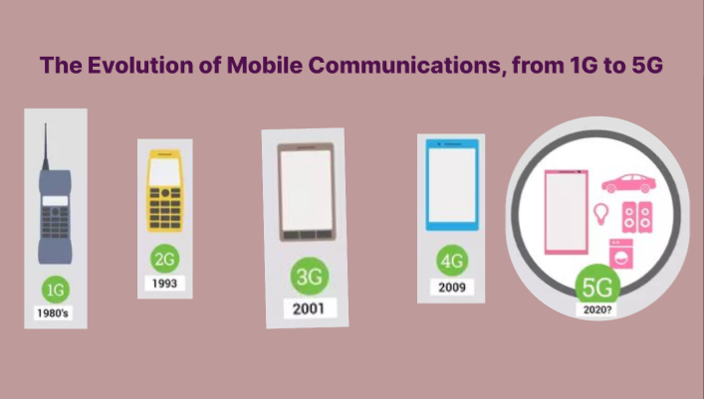

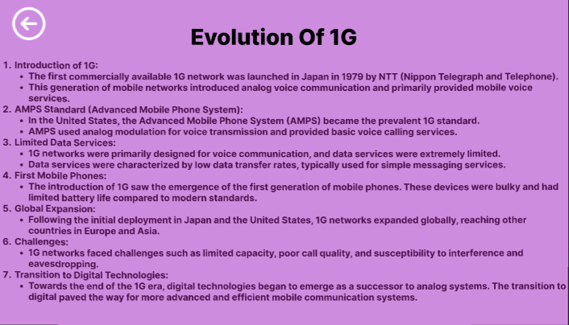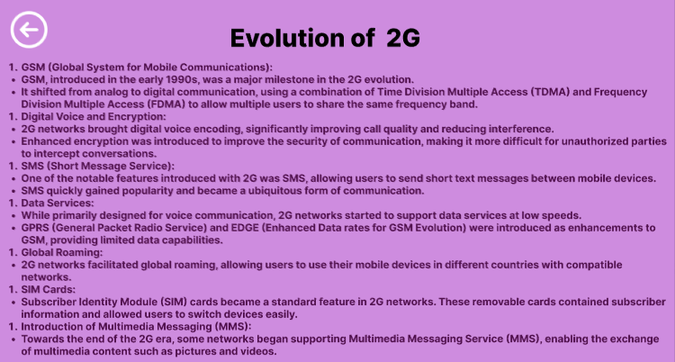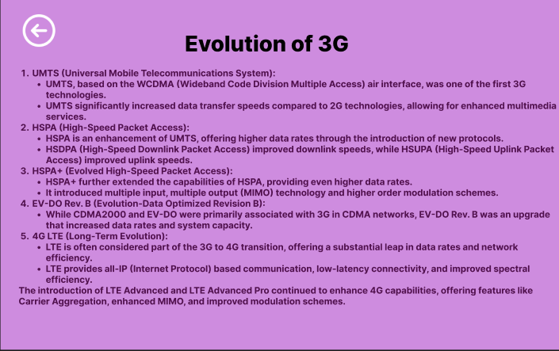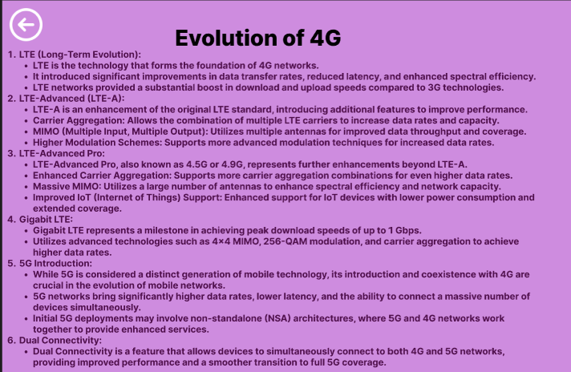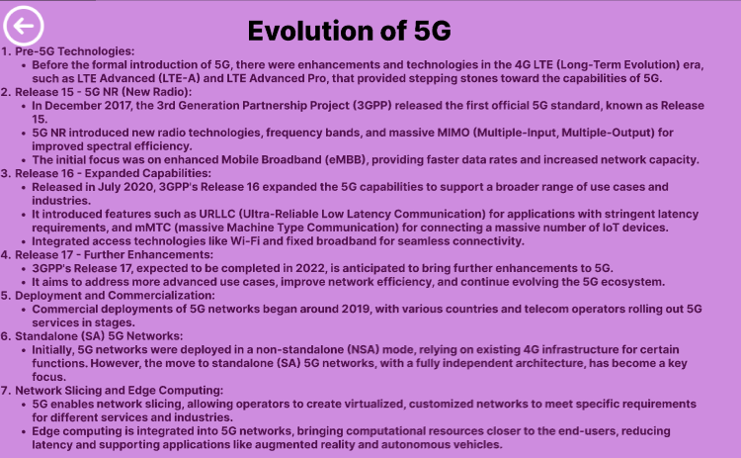

Prototype: -

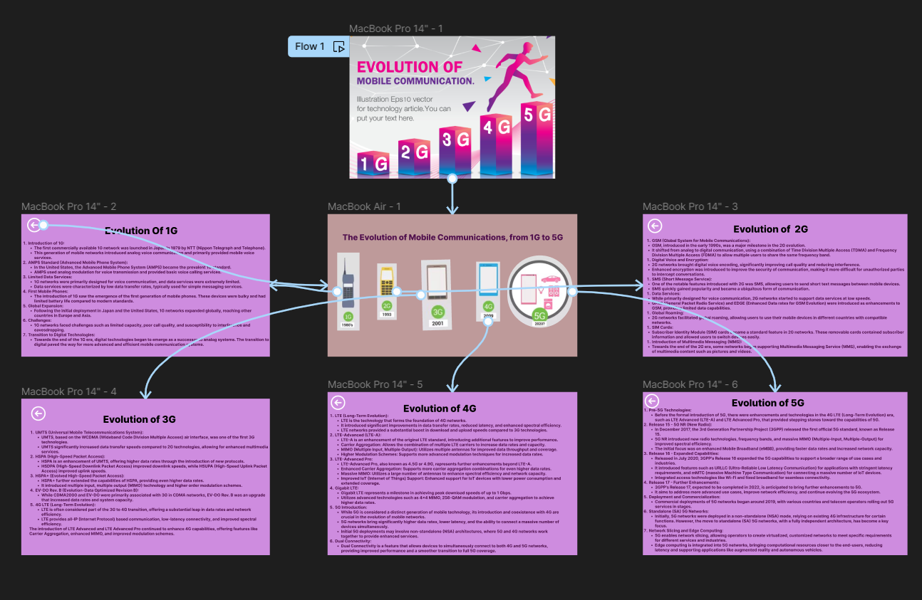

Result: -
Hence an interactive diagram illustrating the evolution from 1G to 5G in Figma is created and executed successfully

13.Design an infographic in Figma comparing mobile communication and mobile computing
Aim: -
Using Figma design an infographic comparing mobile communication and mobile computing
Procedure: -

1. open Figma
2. Create a new file
3. Select the Frames
4. Fill in the content that is required for presentation
5. Design Visual Elements
6. Make it Interactive
7. Add Annotations and Explanations
8. Incorporate Multimedia
9. Storyboard Animation
11. Review and edit the Prototype
12. Save and Share

Design: -

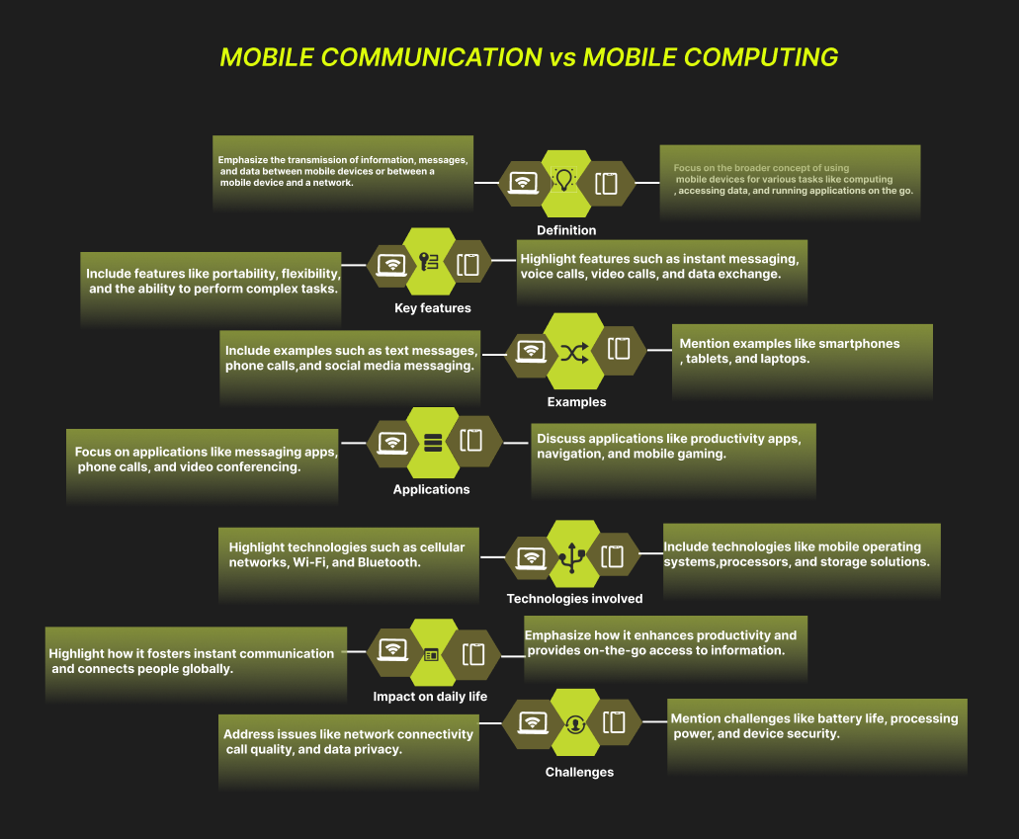

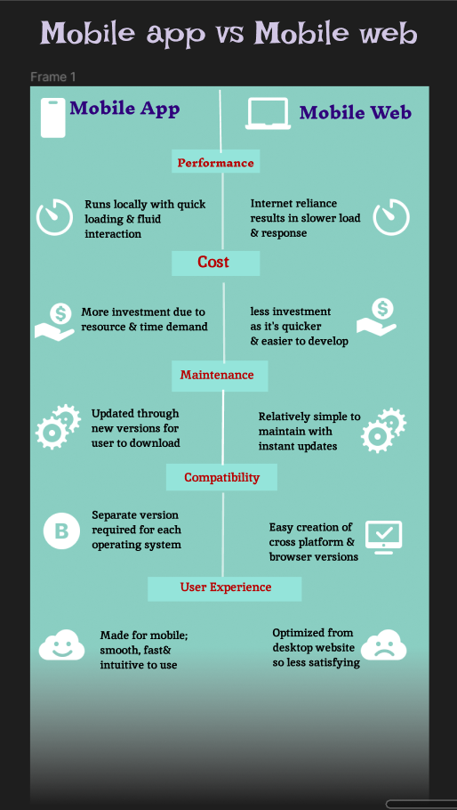

Result: -
An infographic design in Figma comparing mobile communication and mobile computing is created successfully.

14. Develop a flowchart in Figma explaining the operation of General Packet Radio Service (GPRS).

Aim: -
Draw a flowchart in Figma explaining the operation of General Packet Radio Service (GPRS).

Procedure: -
1. open Figma
2. Create a new file
3. Click on the resources icon and click on the plugins
4. Search for the Flow Chart
5. Drag and drop the shapes on the screen
6. Now, enter the content on the shapes and connect them through Arrows.
7. Grouping and alignment
8. Review and edit
9. Save and share

Design: -

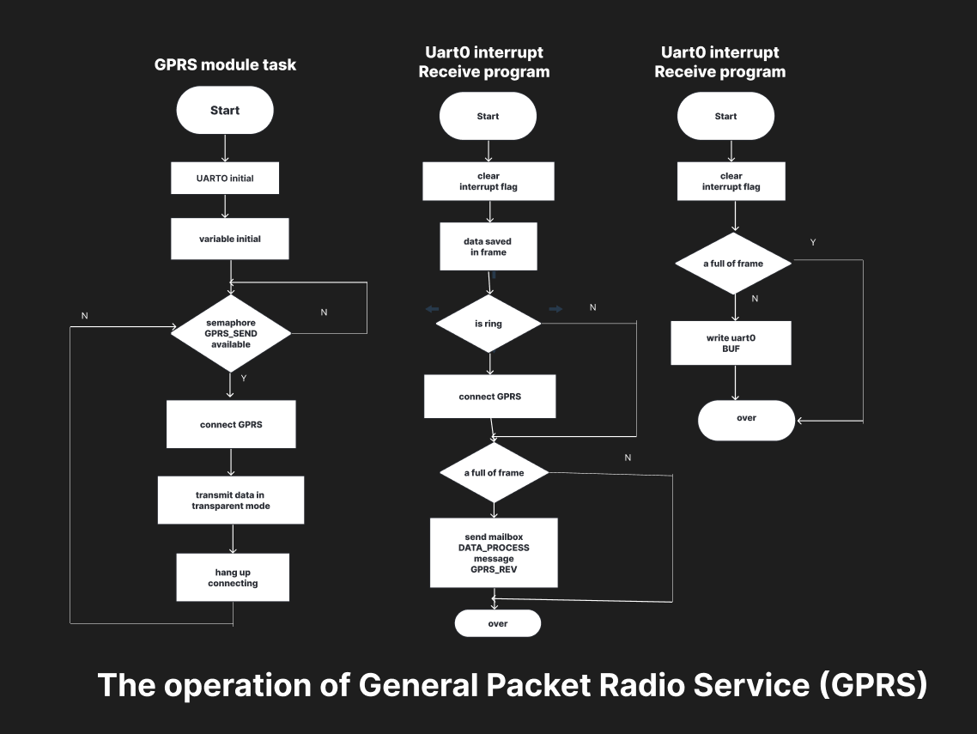

Result: -
Hence the flowchart in Figma explaining the operation of General Packet Radio Service (GPRS) has been drawn successfully.

15) Design an interactive presentation in Figma explaining the issues in mobile IP.

Aim:
To Design an interactive presentation in Figma explaining the issues in mobile IP

Procedure:

- Define Presentation Structure
- Create a Figma Project
- Design Visual Elements
- Make it Interactive
- Add Annotations and Explanations
- Incorporate Multimedia
- Storyboard Animation
- Test the Prototype
- Collaborate and Gather Feedback
- Finalize and Share

Step By Step Procedure :

Interface Of Experiment:


Next Page:

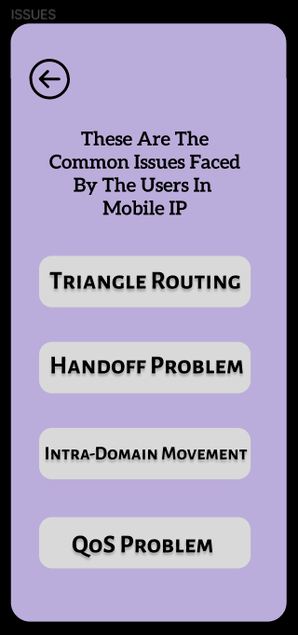

Final Step:

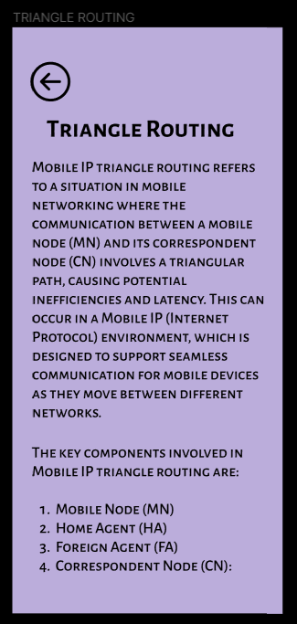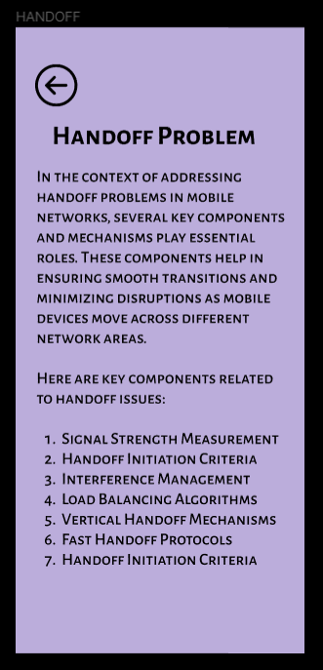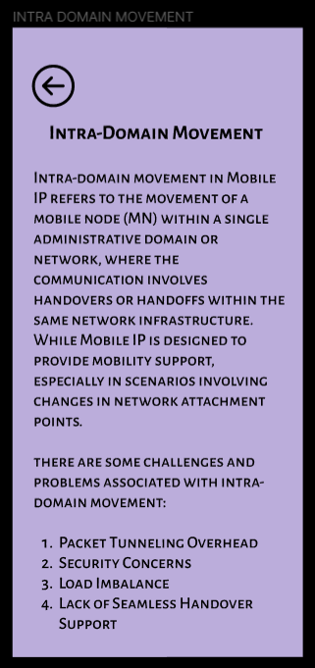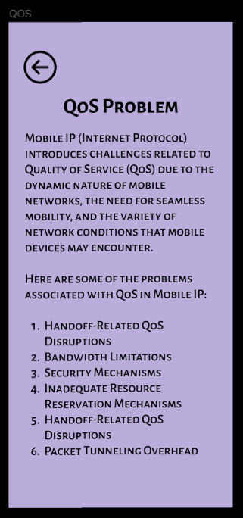
Prototype:

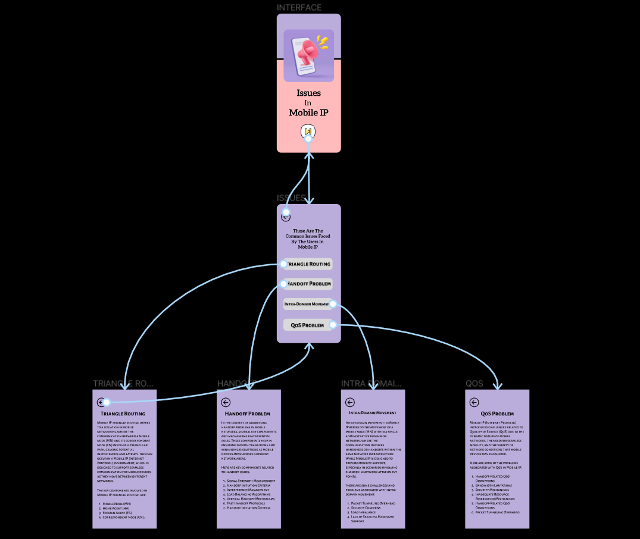

Result:
Hence the interactive presentation in Figma explaining the issues in mobile IP is created and executed successfully.

16. Develop a wireframe for a mobile application that addresses challenges related to ad hoc wireless networks using Figma.

Aim: -
Create a Wireframe for a mobile application that addresses challenges related to ad hoc wireless networks using Figma.

Procedure: -
1. open Figma
2. Create a new file
3. Select the Frames
4. Design Visual Elements
5. Make it Interactive
6. Add icons on the Frame
7. Incorporate Multimedia
8. Storyboard Animation
9. Review and edit the Prototype
10. Save and Share

Design: -

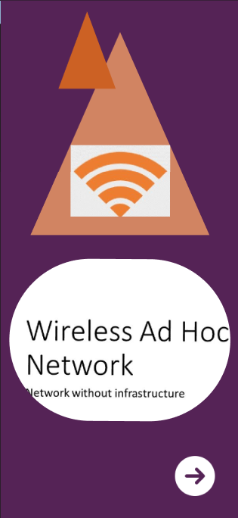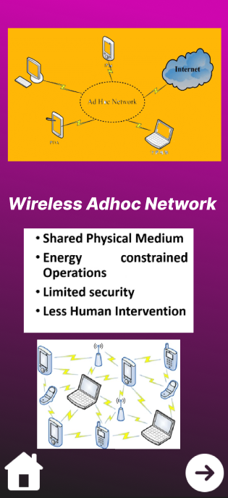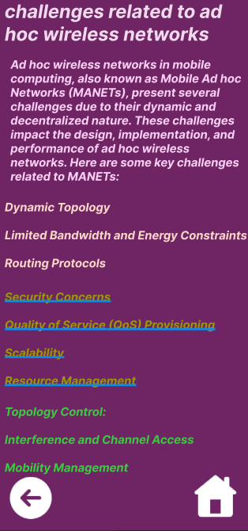

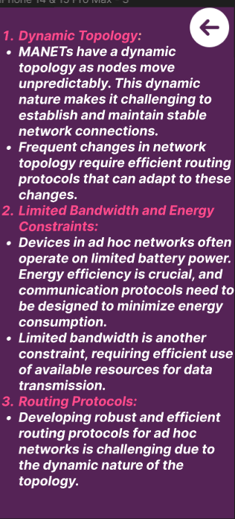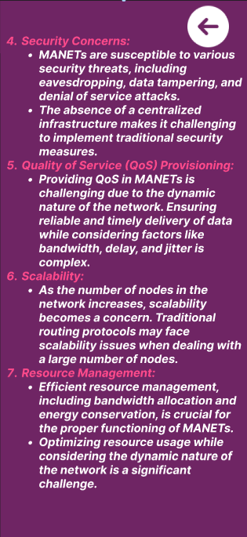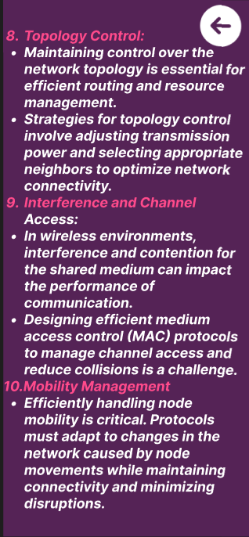

Prototype: -

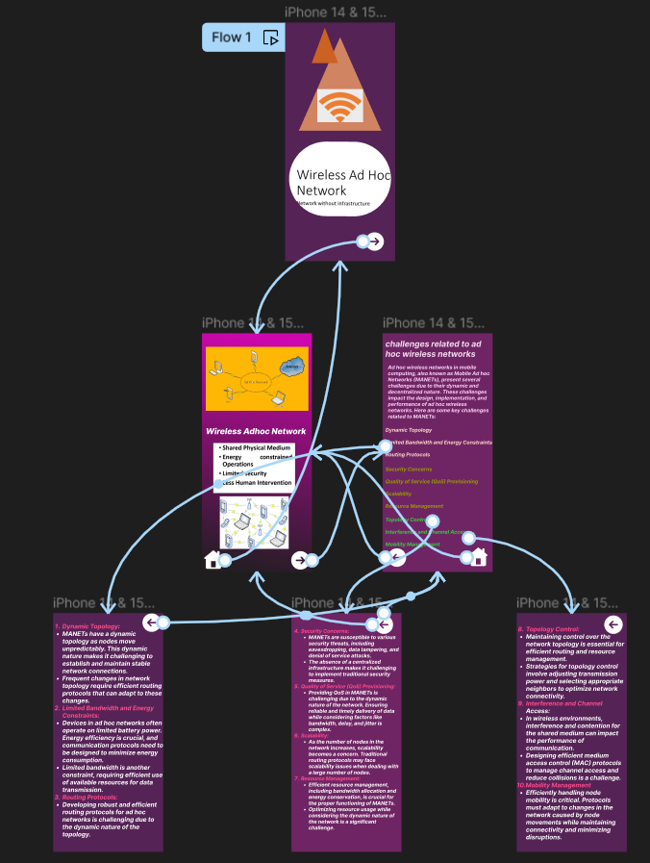

Result: -
Hence a wireframe for a mobile application that addresses challenges related to ad hoc wireless networks using Figma is created and executed successfully

17) Create a visual representation in Figma illustrating the operation of proactive and reactive routing protocols in mobile IP.

Aim:
Create a visual representation in Figma illustrating the operation of proactive and reactive routing protocols in mobile IP.

Procedure:

- Define Presentation Structure
- Create a Figma Project
- Design Visual Elements
- Make it Interactive
- Add Annotations and Explanations
- Incorporate Multimedia
- Storyboard Animation
- Test the Prototype
- Collaborate and Gather Feedback
- Finalize and Share

Step By Step Procedure :

Interface Of Experiment:
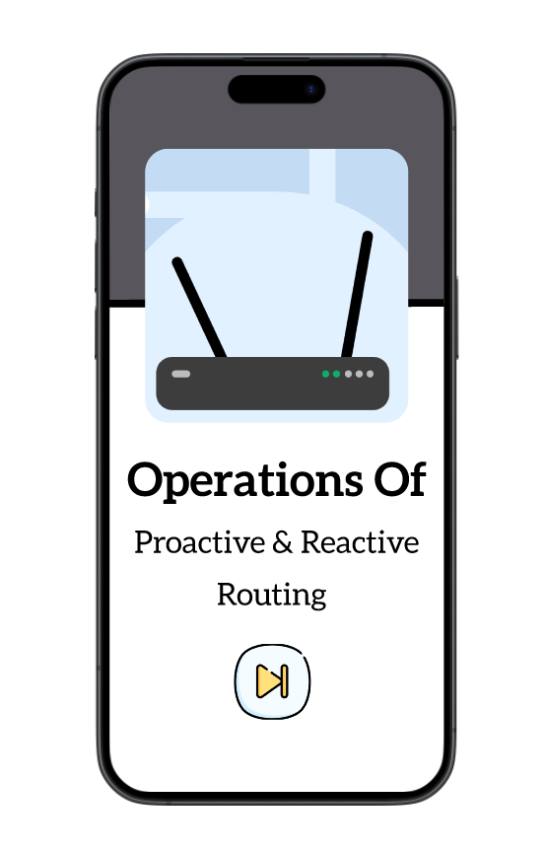
Next Page:

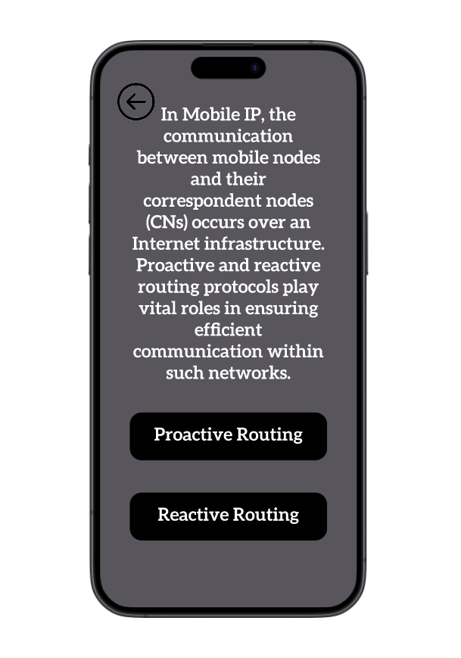

Final Step:

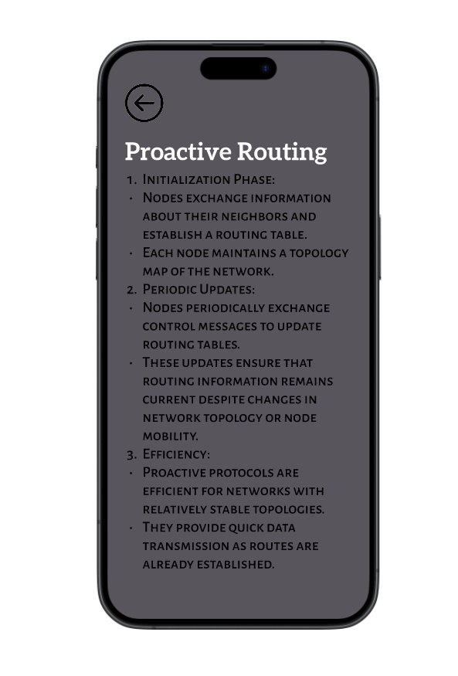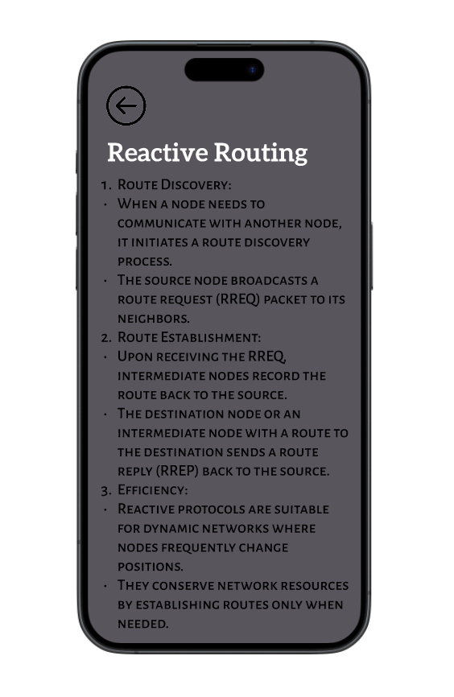

Prototype:

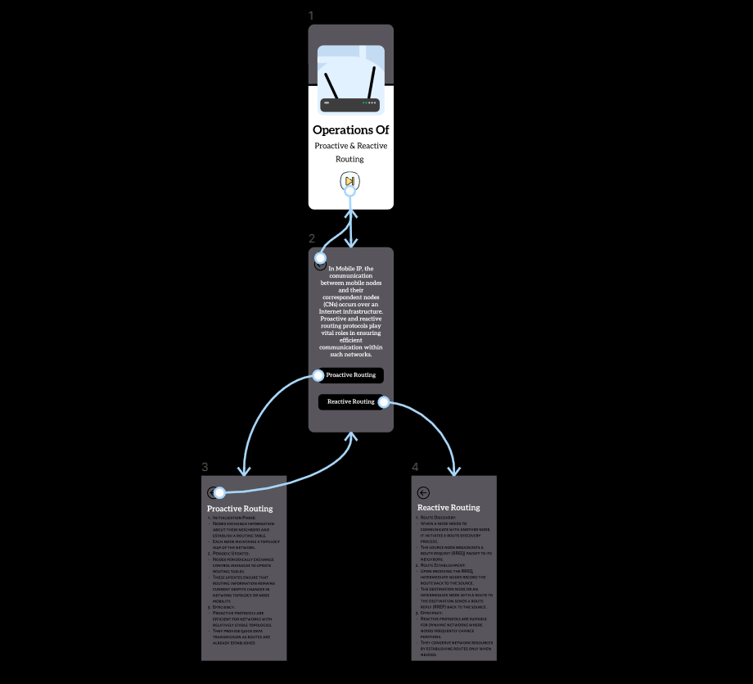

Result:
Hence the illustrating the operation of proactive and reactive routing protocols in mobile IP is created and executed successfully

18) Use Figma to create an infographic comparing and contrasting the architectures of Android, iOS, and Windows.

Aim:
To use Figma to create an infographic comparing and contrasting the architectures of Android, iOS, and Windows.

Procedure:

- Define Presentation Structure
- Create a Figma Project
- Design Visual Elements
- Make it Interactive
- Add Annotations and Explanations
- Incorporate Multimedia
- Storyboard Animation
- Test the Prototype
- Collaborate and Gather Feedback
- Finalize and Share

Step By Step Procedure :

Interface Of Experiment:
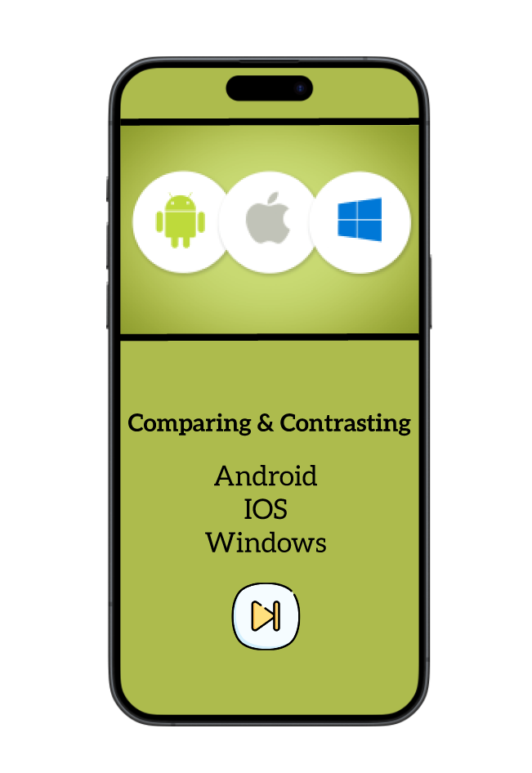
Next Page:
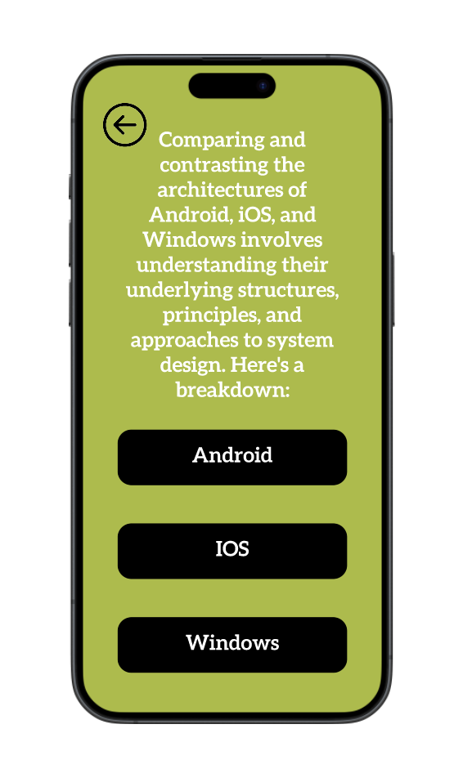
Final Step:
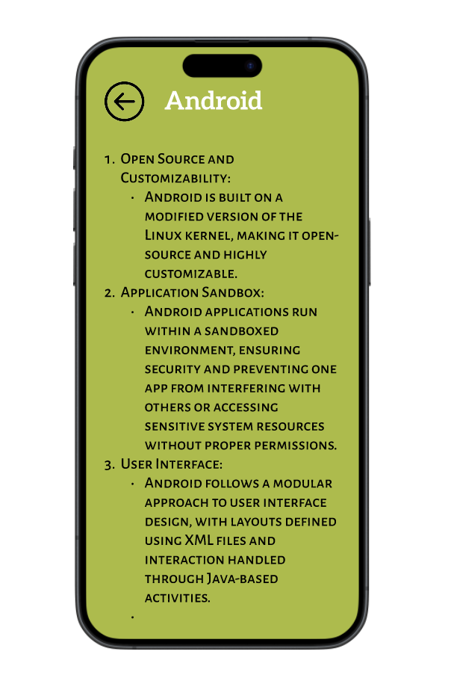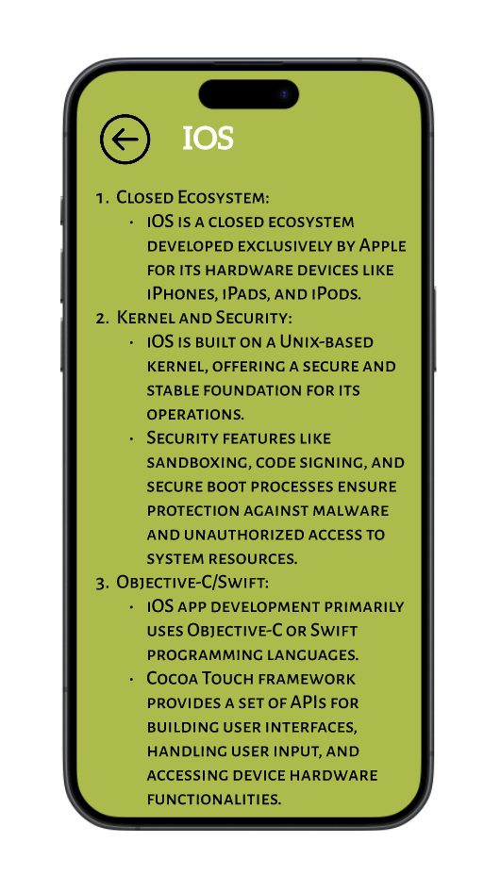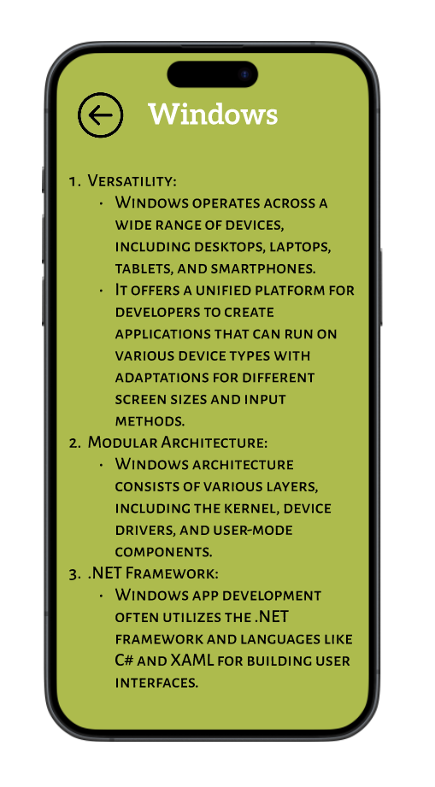

Prototype:
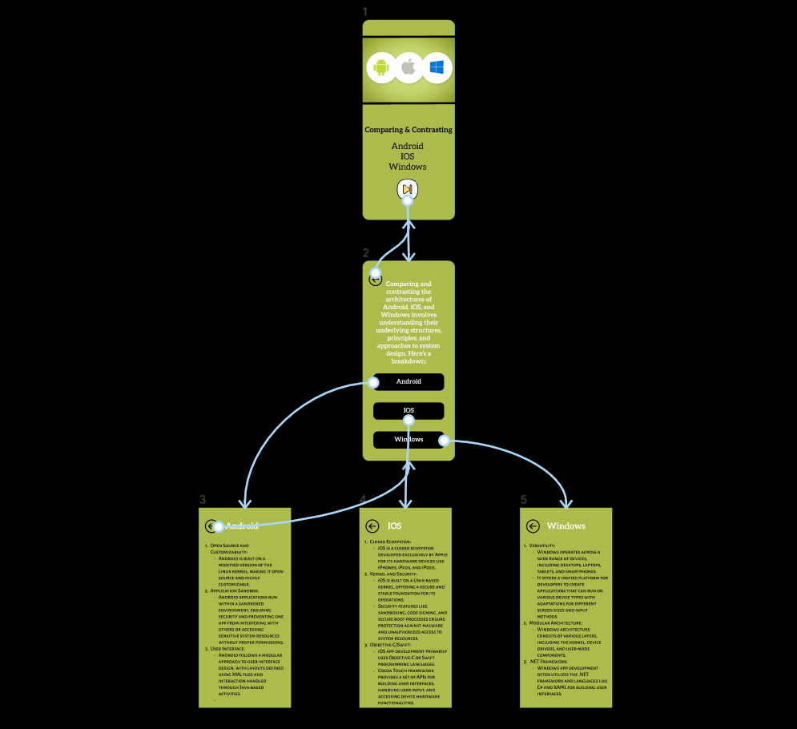

Result:
Hence the comparing and contrasting the architectures of Android, iOS, and Windows is created and executed successfully.

19) Develop a user interface prototype for an Android application using Figma.

Aim:
To Develop a user interface prototype for an Android application using Figma.

Procedure:

- Create a file
- Add The First Frame
- Add Shapes
- Add Text
- Create The Second Frame
- Add Prototyping
Step By Step Procedure :

Interface Of Experiment:

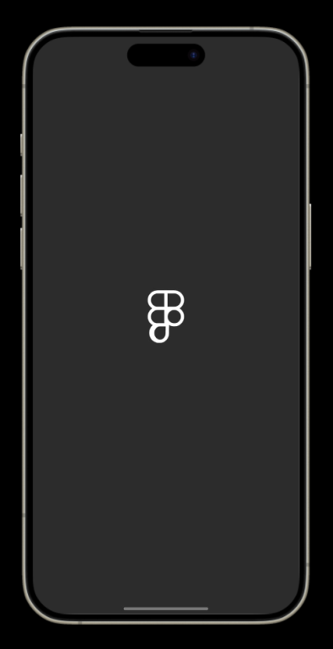

Next Page:

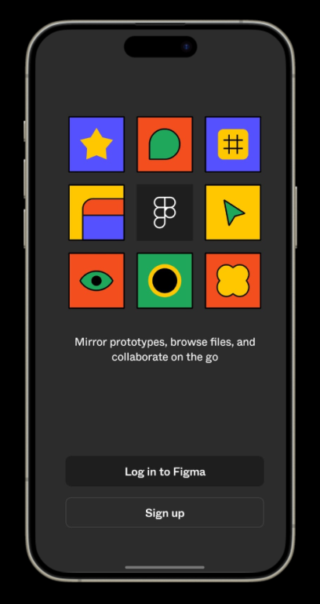

Login And Signup Page:

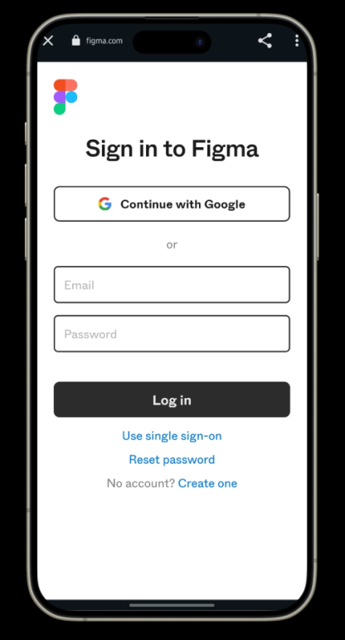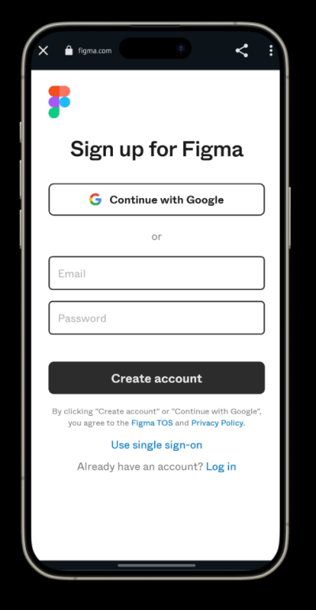

Final Step:

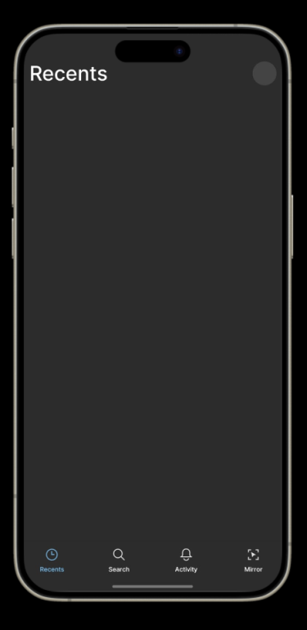

Prototype:

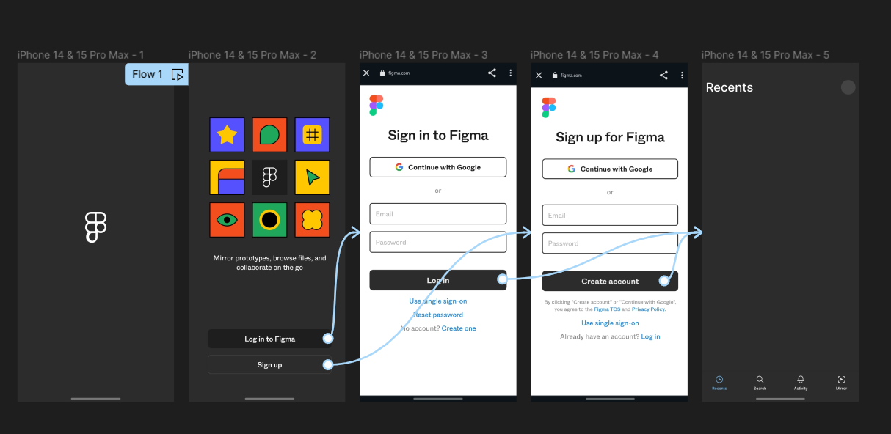

Result:
Hence the Develop a user interface prototype for an Android application created and executed successfully

20) Design a wireframe in Figma for a mobile application showcasing power management approaches.

Aim:
Design a wireframe in Figma for a mobile application showcasing power management approaches.

Procedure:

- Create a file
- Add The First Frame
- Add Shapes
- Add Text
- Create The Second Frame
- Add Prototyping
Step By Step Procedure :

Interface Of Experiment

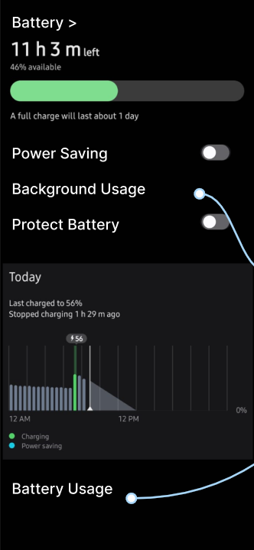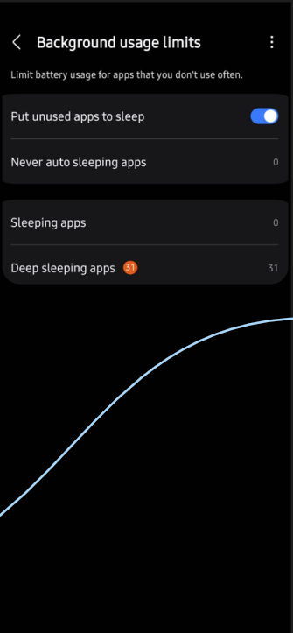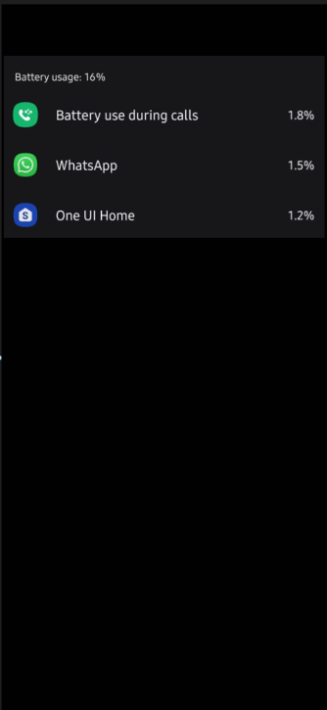

Prototype: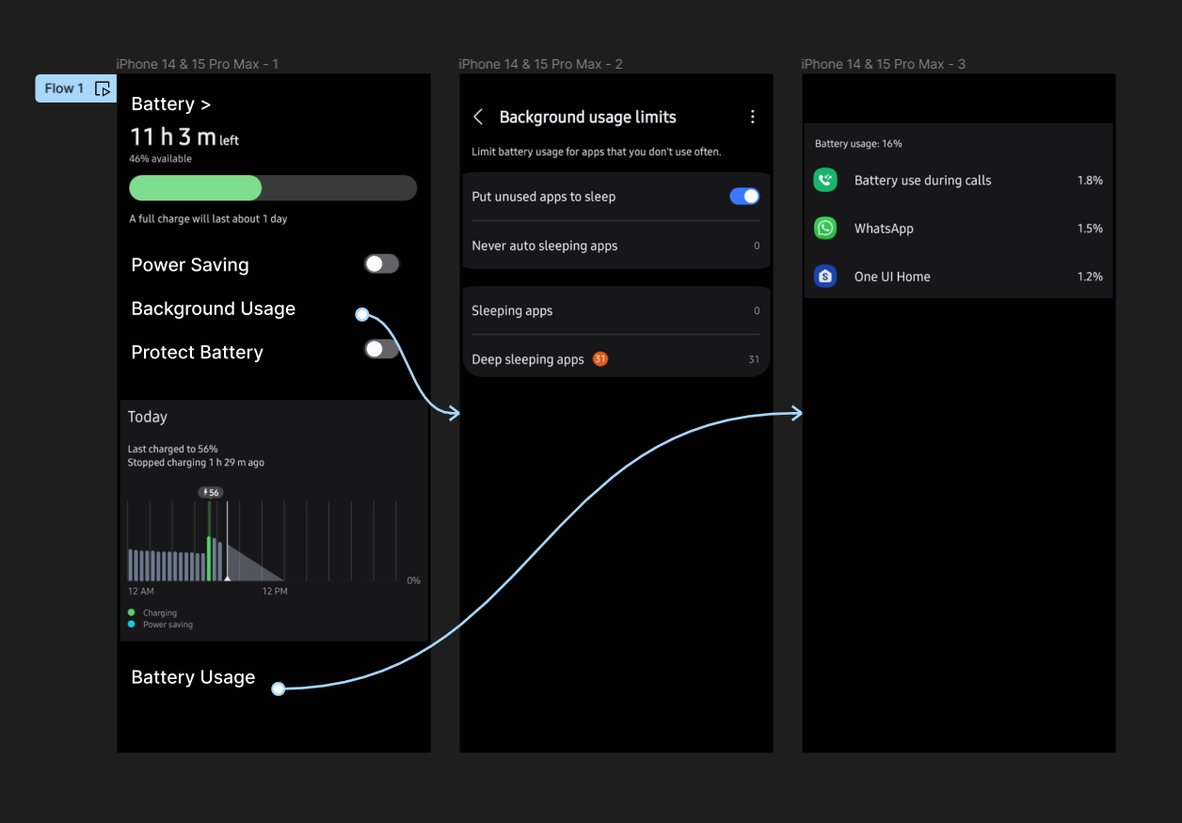

Result:
Hence the mobile application showcasing power management is created and executed successfully.

21) In Figma, design a mobile app interface that prioritizes user connectivity and convenience. Highlight key elements.

Aim:
To design a mobile app interface that prioritizes user connectivity and convenience. Highlight key elements.

Procedure:
- Create a file
- Add The First Frame
- Add Shapes
- Add Text
- Create The Second Frame
- Add Prototyping
Step By Step Procedure :

Interface Of Experiment


Menu Page:
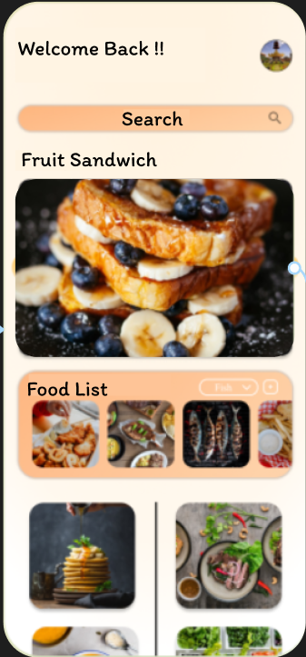
Final Step:
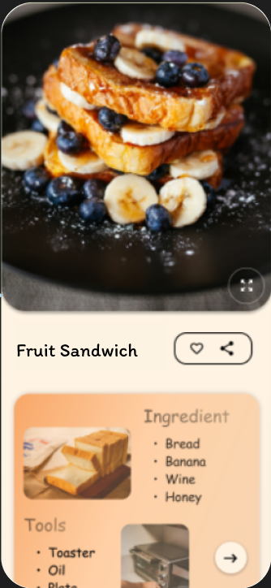

Prototype:
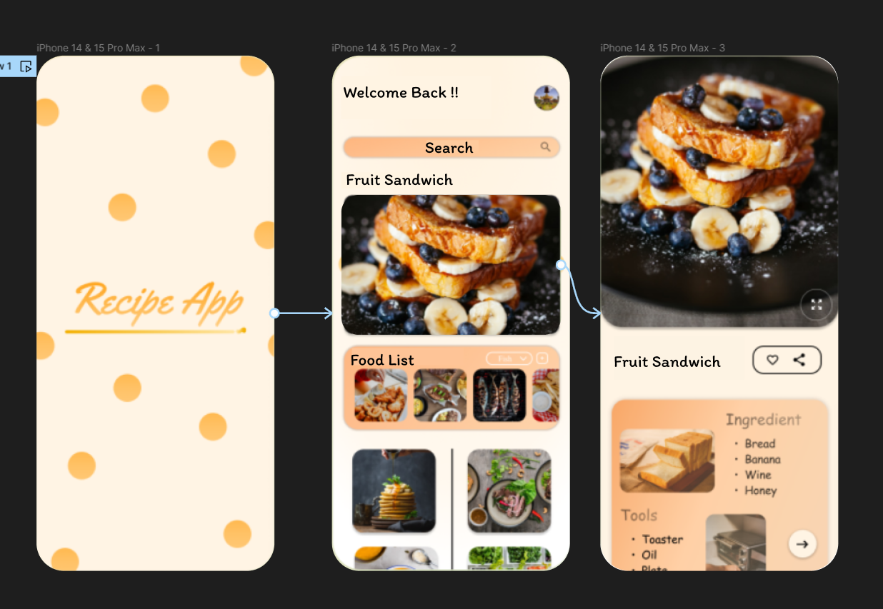
Result:
Hence the mobile app interface that prioritizes user connectivity created and executed successfully.

22) Create wireframes illustrating how localization features can be integrated into a mobile app, ensuring a user-friendly design in Figma.

Aim:Wireframes illustrating how localization features can be integrated into a mobile app using Figma
Procedure: -
- Open Figma
- Create a new file
- Select the Frames
- Design Visual Elements
- Make it Interactive
- Add icons on the Frame
- Incorporate Multimedia
- Storyboard Animation
- Review and edit the Prototype
- Save and Share

Design:
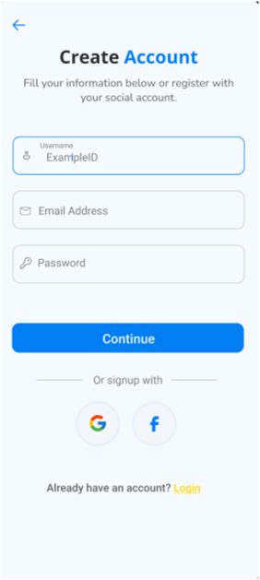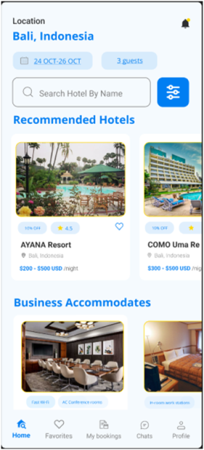
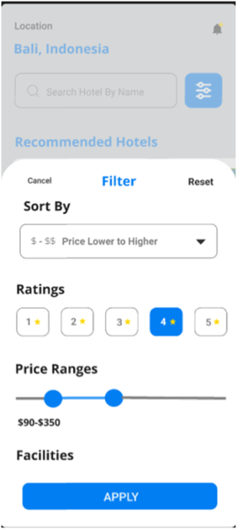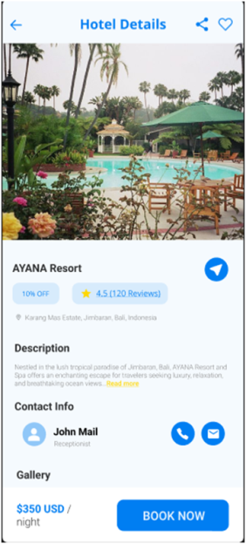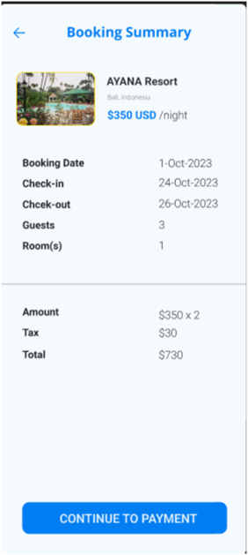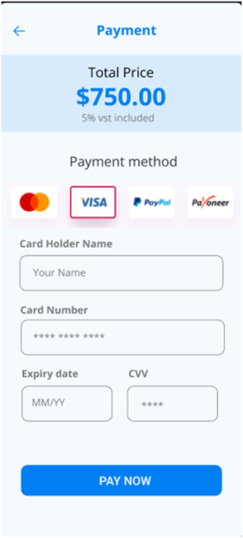

Prototype: -
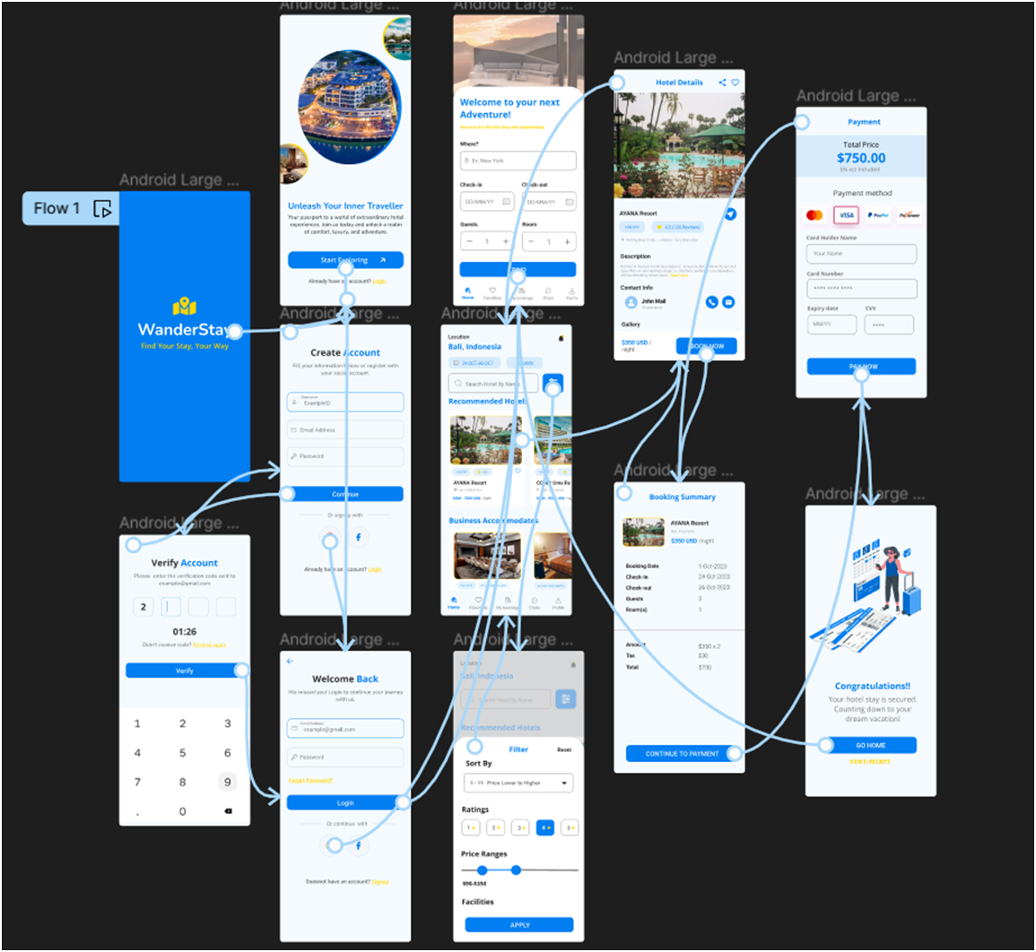
Result: -
Hence the localization features can be integrated into a mobile app is created and executed successfully

23. Develop a user interface prototype in Figma showcasing security measures for a mobile app. Emphasize the intuitive design for user personalization.

Aim:
Developing a user interface prototype in Figma showcasing security measures for a mobile app.

Procedure:
- Define Presentation Structure
- Create a Figma Project
- Design Visual Elements
- Make it Interactive
- Add Annotations and Explanations
- Incorporate Multimedia
- Storyboard Animation
- Test the Prototype
- Collaborate and Gather Feedback
- Finalize and Share

Design:

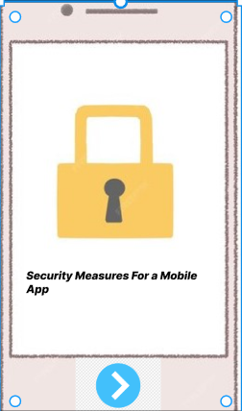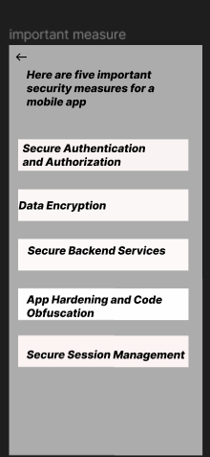

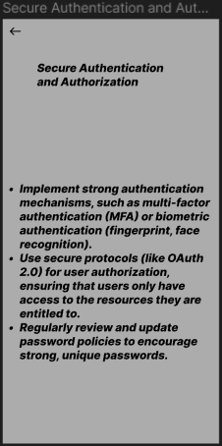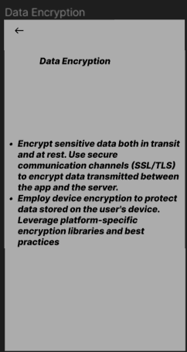

Prototype:
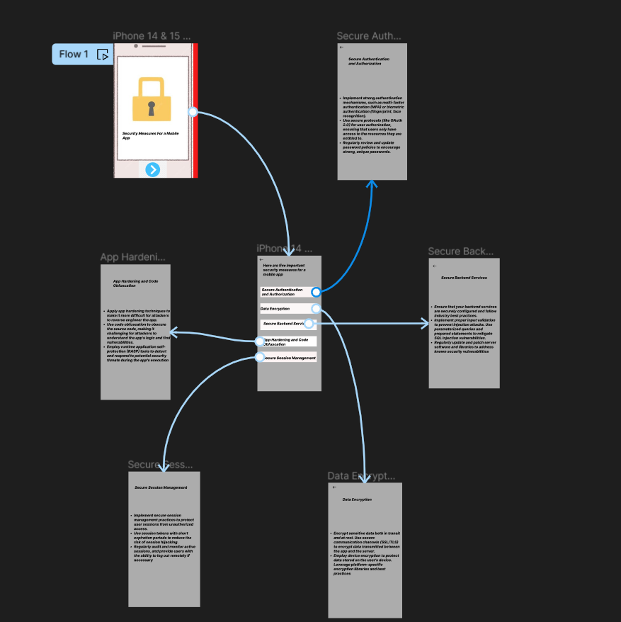

Result:
Hence an user interface prototype in Figma showcasing security measures for a mobile app
have been created successfully

24 . Use Figma to design a flowchart demonstrating the lifecycle of an Android Intent, including explicit and implicit intents.

Aim : Design a flowchart demonstrating the lifecycle of an Android Intent, including explicit and implicit intents.
Procedure: -
- Open Figma
- Create a new file
- Click on the resources icon and click on the plugins
- Search for the Flow Chart
- Drag and drop the shapes on the screen
- Now, enter the content on the shapes and connect them through Arrows.
- Grouping and alignment
- Review and edit
- Save and share
Design :
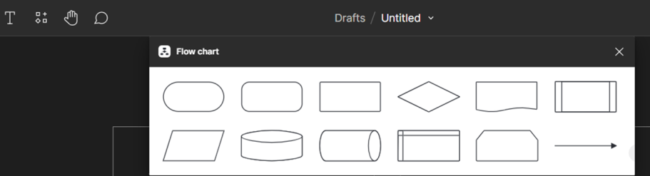
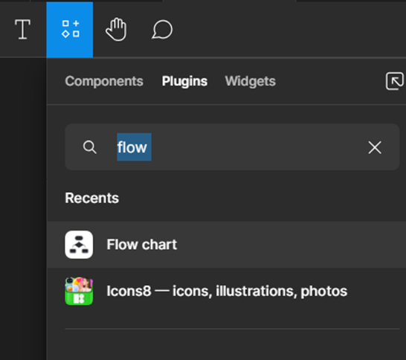
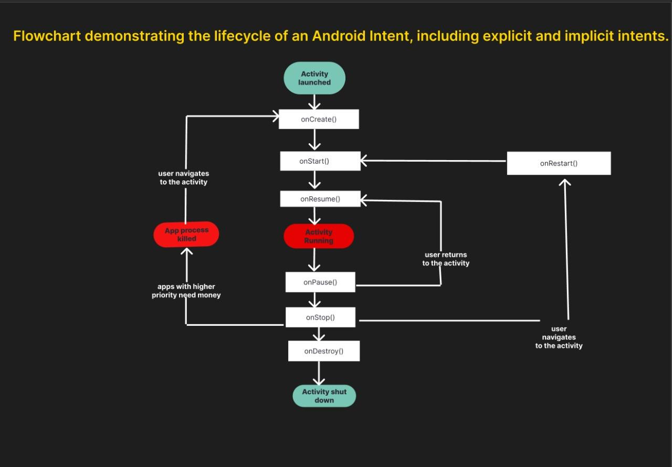

Result :
Hence the flowchart in Figma explaining thelifecycle of an Android Intent, including explicit and implicit intents.

25) Create a wireframe for an Android app that utilizes background services. Use Figma to illustrate the service interactions and data flow.

Aim:
Create a wireframe for an Android app that utilizes background services using Figma
Procedure:
- Open Figma
- Create a new file
- Select the Frames
- Design Visual Elements
- Make it Interactive
- Add icons on the Frame
- Incorporate Multimedia
- Storyboard Animation
- Review and edit the Prototype
- Save and Share

Design

Prototype:

Result:
Hencea wireframe for an Android app that utilizes background services. Using Figma have been created successfully

26) Design wireframes for a mobile app showcasing data replication techniques. Use Figma to demonstrate the synchronization process.

Aim:
ToDesign a mobile app showcasing data replication techniques using figma

Procedure:
- Open Figma
- Create a new file
- Select the Frames
- Design Visual Elements
- Make it Interactive
- Add icons on the Frame
- Incorporate Multimedia
- Storyboard Animation
- Review and edit the Prototype
- Save and Share
Design:

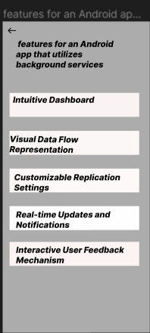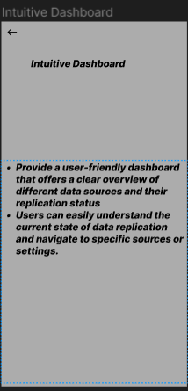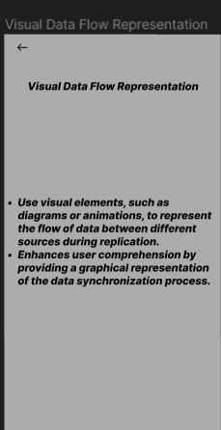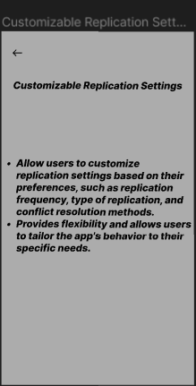

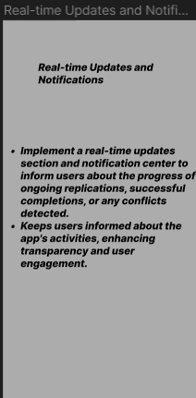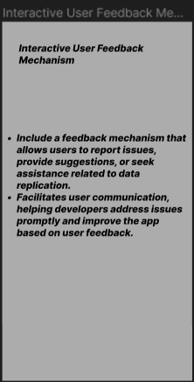

Prototype:
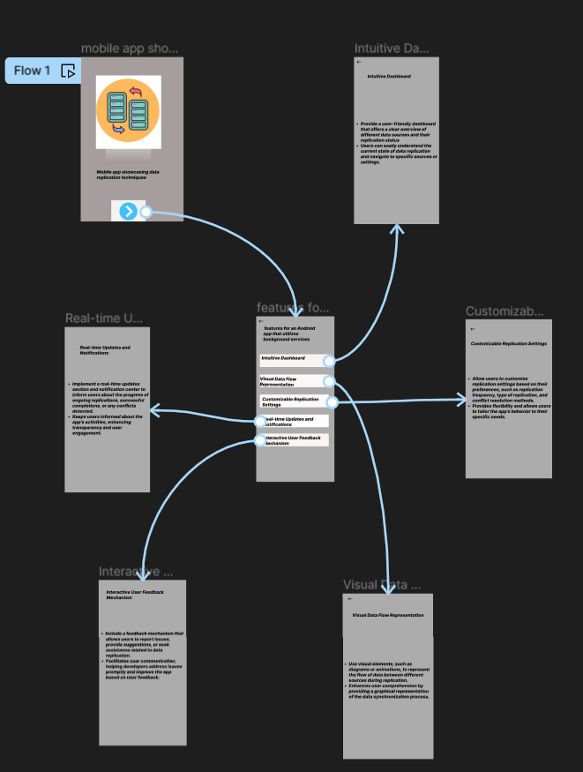
Result: Hencea mobile app showcasing data replication techniques using figma have been created successfully

27.Use Figma to create an interactive presentation comparing the Core Video framework in iOS and the multimedia framework in Android.

Aim: Create an interactive presentation comparing the Core Video framework in iOS and Android using Figma

Procedure:

1.Define Presentation Structure
2.Create a Figma Project
3.Design Visual Elements
4.Make it Interactive
5.Add Annotations and Explanations
6.Incorporate Multimedia
7.Storyboard Animation
8.Test the Prototype
9.Collaborate and Gather Feedback
10.Finalize and Share

Design:

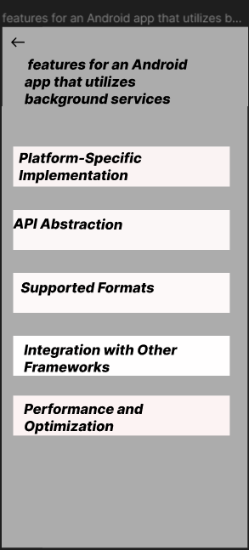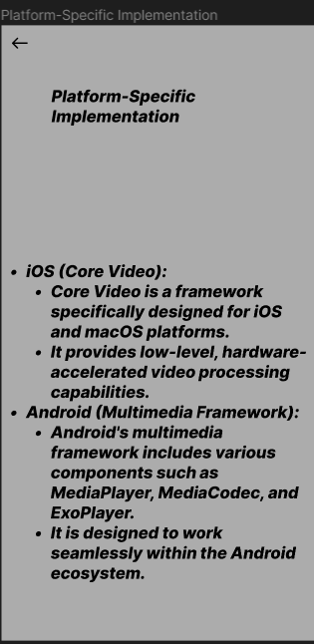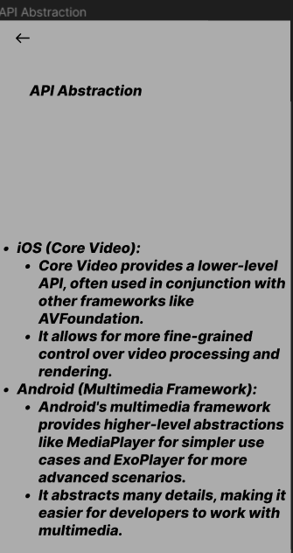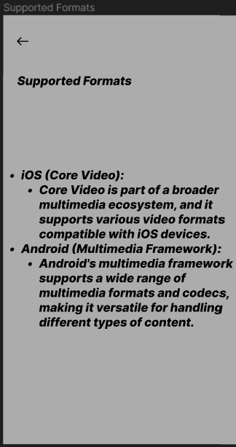

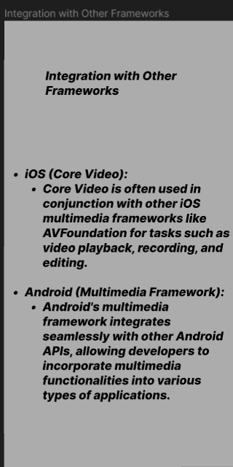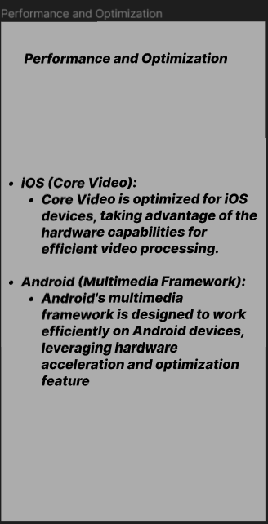

Prototype:
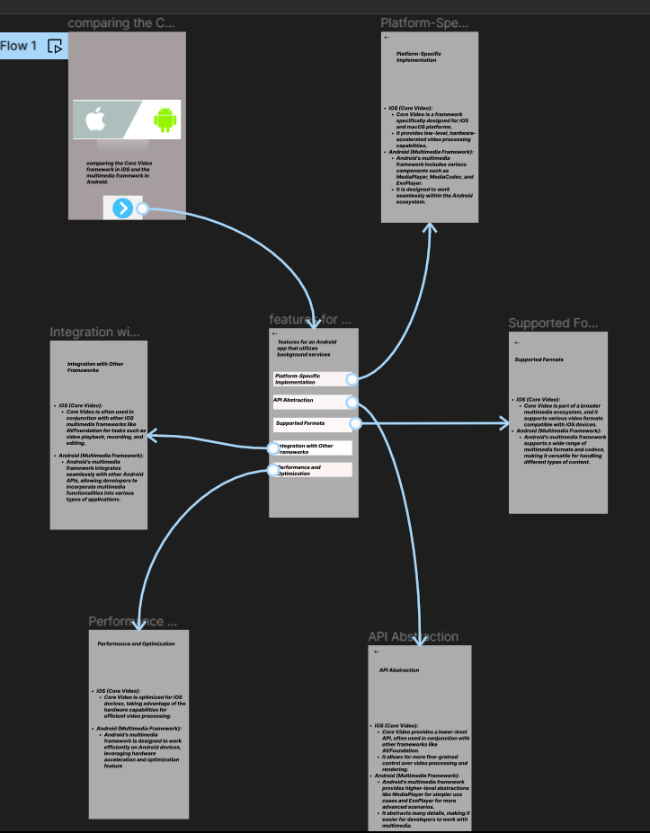
Result: Hencean interactive presentation comparing the Core Video framework in iOS and Android using Figma have been created successfully

28. Design a wireframe in Figma for a multimedia-rich mobile app, incorporating elements from both Core Video and Core Media frameworks.

Aim:Design a wireframe for a multimedia-rich mobile app, incorporating elements from both Core Video and Core Media frameworks using figma

Procedure:
- Open Figma
- Create a new file
- Select the Frames
- Design Visual Elements
- Make it Interactive
- Add icons on the Frame
- Incorporate Multimedia
- Storyboard Animation
- Review and edit the Prototype
- Save and Share

Design:
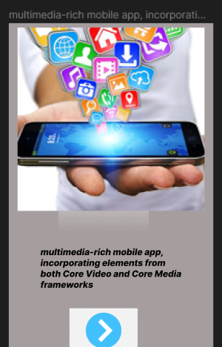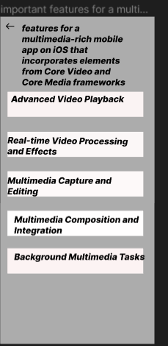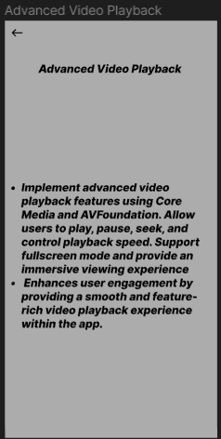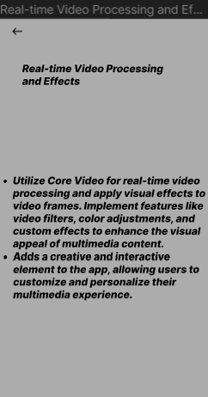

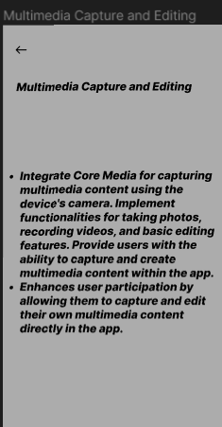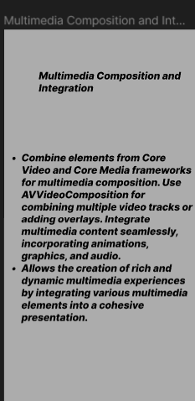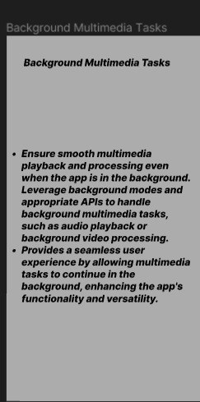

Prototype:
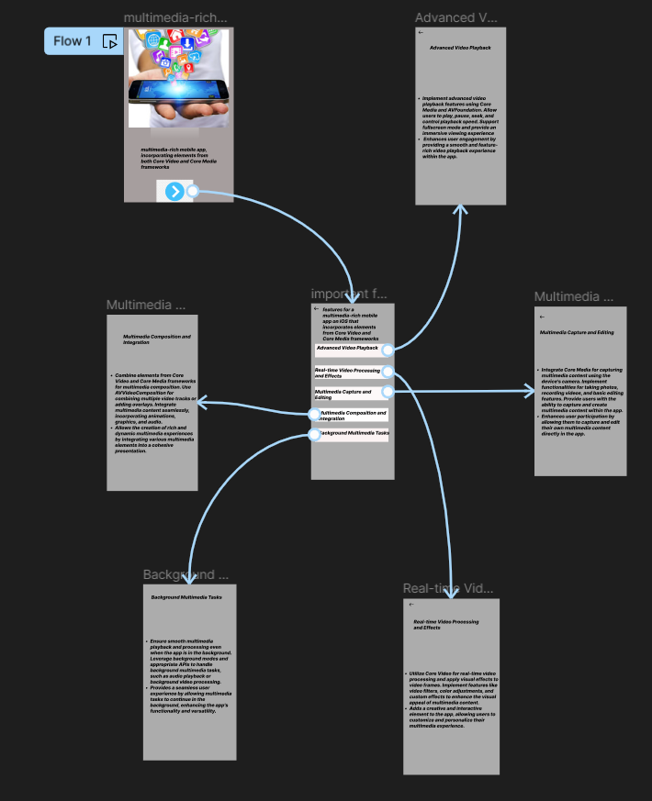
Result: A wireframe for a multimedia-rich mobile app, incorporating elements from both Core Video and Core Media frameworks using figma have been created successfully
29.Create wireframes for a collaborative mobile app using Figma, showcasing the peer-to-peer interactions in real-time.
Aim: Wireframes for a collaborative mobile app,showcasing the peer-to-peer interactions in real-time using figma

Procedure:
- Open Figma
- Create a new file
- Select the Frames
- Design Visual Elements
- Make it Interactive
- Add icons on the Frame
- Incorporate Multimedia
- Storyboard Animation
- Review and edit the Prototype
- Save and Share
Design:

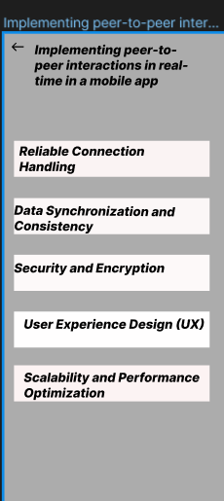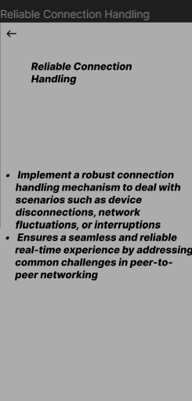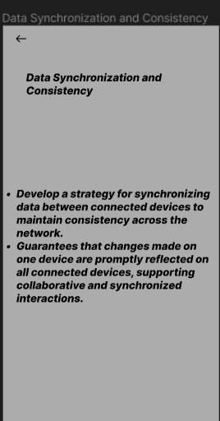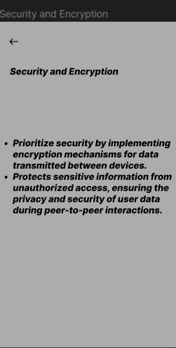
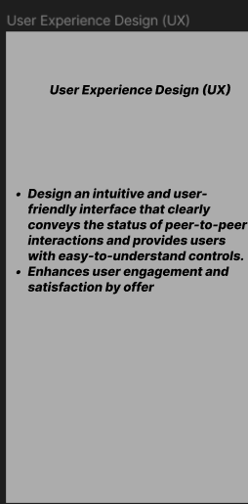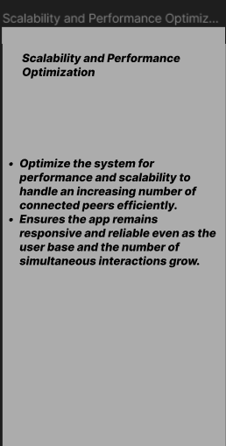

Prototype:
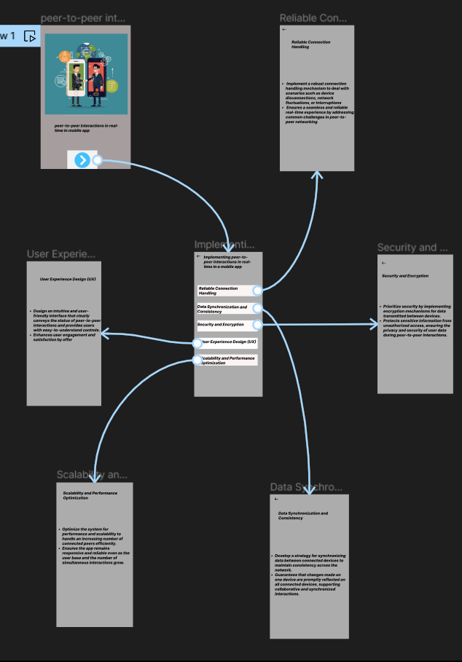
Result:
HenceWireframes for a collaborative mobile app,showcasing the peer-to-peer interactions in real-time using figma have been created successfully

30) Develop wireframes for a visually rich mobile app with optimized graphics and UI performance, using Figma to showcase the design principles.

Aim:
To Develop wireframes for a visually rich mobile app with optimized graphics and UI performance, using Figma to showcase the design principles.

Procedure:
- Open Figma
- Create a new file
- Select the Frames
- Design Visual Elements
- Make it Interactive
- Add icons on the Frame
- Incorporate Multimedia
- Storyboard Animation
- Review and edit the Prototype
- Save and Share
Design:
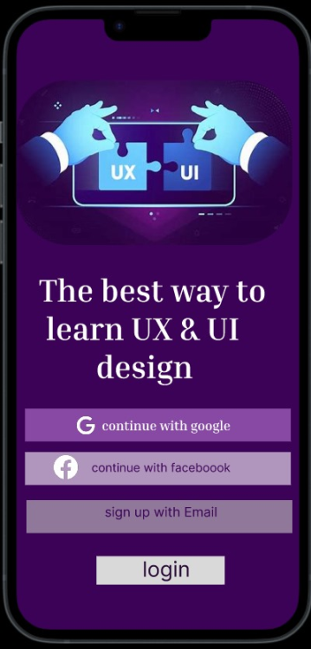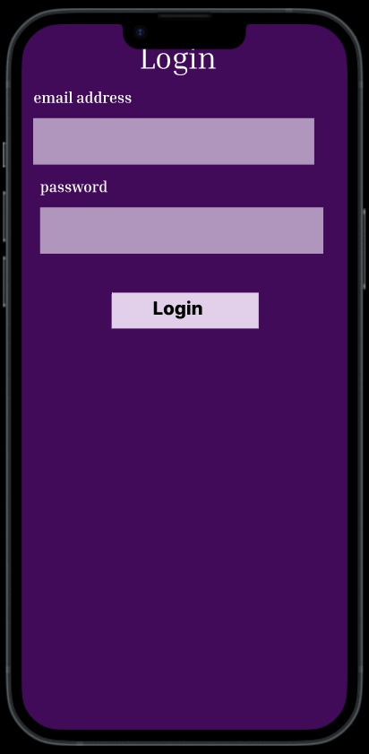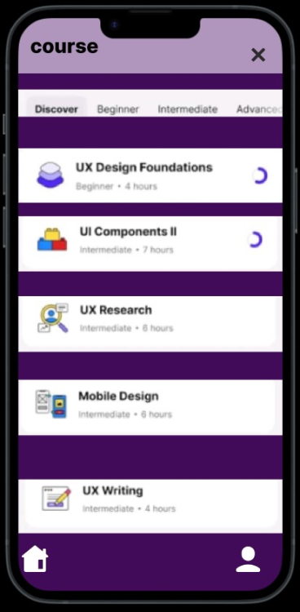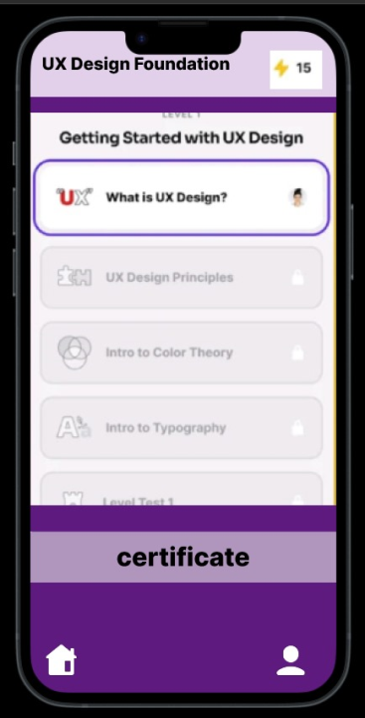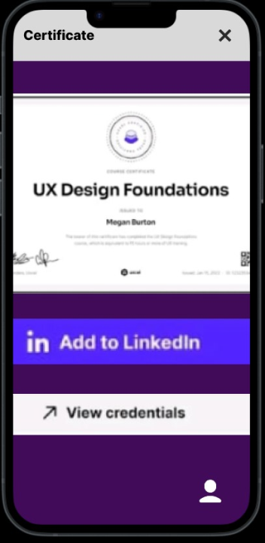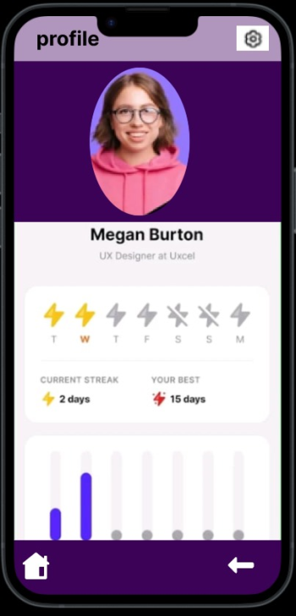
Prototype:
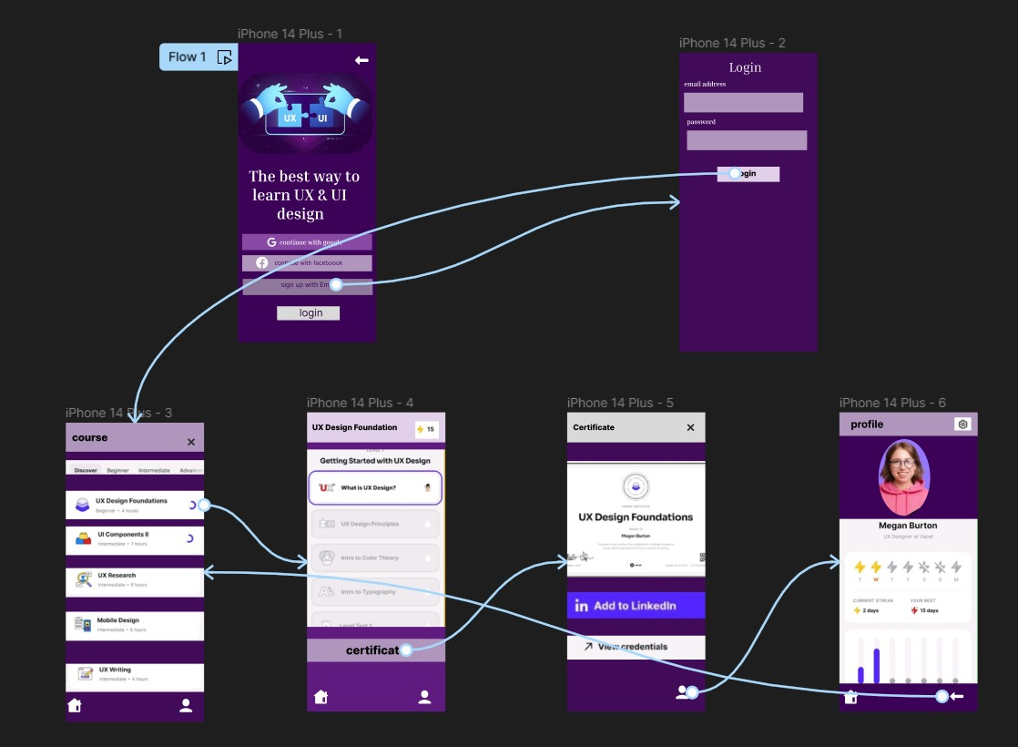

Result:
Thus The Develop wireframes for a visually rich mobile app with optimized graphics and UI performance is created and executed successfully.

